Testing Overall and Synergistic Campaign Effects in a Partisan Statewide Election

Daron Shaw
University of Texas at Austin
Government Department
dshaw@ausin.utexas.edu
512-232-7275

Christopher Blunt
Overbrook Research
ccblunt@overbrookresearch.com
217-390-8006

Brent Seaborn
TargetPoint Consulting
bseaborn@targetpointconsulting.com
703-535-8505

Abstract
Although studies based on field experiments and large-N surveys have enhanced our understanding of how campaigns affect U.S. elections, few of these projects have (1) considered the synergistic effects of different aspects of the campaign, (2) focused on statewide, partisan elections, or (3) considered the durability of any estimated campaign effects. We rely on a massive field experiment from the 2014 Texas gubernatorial campaign to assess the individual, synergistic, and collective impact of a variety of outreach modes on the electorate. The data demonstrate durable synergistic and overall campaign effects on voters’ attitudes towards the sponsoring candidate, with lesser effects on turnout. In addition, while the results indicate that television is rightly considered the most effective mover of voters, radio and online communication also have notable effects and may, in fact, offer a better return on investment.

Introduction
Since the late 1990s, political science research has shed considerable light on the influence of common modes of campaign communication—mail, telephones, and in-person contacting—on U.S. voters and elections. But the effects of the dominant modes—broadcast and online advertising—as well as the synergistic and overall effects of electioneering, remain a matter of dispute. The reasons for this are straightforward: American campaigns are noisy, and it is difficult to isolate the independent impact of singular forms of outreach. More generally, calculating the sum of these impacts and offering estimates of the interactive and total effects of the campaign is close to impossible.
Still, the allure of learning more about this essential element of democratic functioning is compelling. As many have observed, campaigns are the connective tissue between voters and elected officials (Campbell, 2008). Campaigns are where candidates convey promises and commitments that bind them to specific policy acts as public officials. They establish the basis for accountability and, in no minor way, democracy.
Beyond their importance for democratic theory, we are also fascinated with campaigns because of the time, energy, and money they consume. Are they really worth the effort we invest in them? Indeed, the disbelieving reaction of practitioners and pundits to findings of “minimal effects” on the part of some campaign scholars is no doubt caused by the assumption that smart, rational people could not possibly spend so much for so little effect.
Against this backdrop, we want to know if campaigns successfully persuade and mobilize voters. To engage this question, the primary goals of this study are: (1) to gauge the distinct and synergistic effects of different forms of campaigning, as designed and executed by real-life practitioners, and (2) to estimate the cumulative effects of a campaign. To attain these goals, we rely on a field experiment testing the simultaneous effects of several distinct forms of campaign communication in a statewide, partisan campaign for governor of Texas.

Theorizing about Campaign Effects
Modes Matter
When considering the impact of electioneering, we think it most instructive to focus on the “mode” of outreach. Campaign modes vary on two salient dimensions: frequency and targeting precision. Frequency refers to the number of times that an individual voter is exposed to a campaign message. Targeting precision refers to the match between the campaign message and the attitudes of the individual voters. Campaign effects are most likely when receptive voters are repeatedly exposed to persuasive messages.
Unfortunately for most practitioners, campaign modes that offer the greatest potential with respect to frequency and repetition (television and radio) are also broadcast to many unreceptive voters. Conversely, campaign modes that offer the greatest potential for precise and personal targeting (digital, mail, phones, and face-to-face) are the most easily discarded, blocked, or refused by voters. This conundrum is borne out by empirical analyses, which show substantial but temporary effects for television advertising (Gerber et al., 2010) and small effects for digital, mail, and phones (Gerber and Green, 2004; Huber and Arceneaux, 2007). In light of all this, we assume that the frequency and targeting precision of campaign modes should condition their ability to influence voters as follows:

 | High Frequency/Reach | Low Frequency/Reach
Precise Targeting | Highly significant aggregate effects. | Minimal aggregate effects.
Imprecise Targeting | Significant, temporary aggregate effects. | No aggregate effects.

Voter Receptivity Also Matters
Additional leverage can be gained on the question of aggregate campaign effects by considering voter (or “receiver”) characteristics. Previous studies demonstrate that persuasive effects—and, consequently, campaign effects—are substantially conditioned by the attitudinal predispositions of the audience. Most notably, a voter’s level of political awareness and partisanship dictate whether or not a campaign message is likely to be persuasive. Political awareness, in particular, increases the likelihood of “reception” (Zaller, 1992), but it also leads to greater stores of information and thus lessens the likelihood that voters will “yield” to new information. High intensity election campaigns experienced by low awareness voters are therefore often regarded as the most likely to produce an impact (e.g., Ridout and Franz, 2011).
In addition to political awareness, partisanship should moderate how voters react to campaign information. Independents, who lack a partisan filter that causes them to resist information coming from a certain source, should be most receptive to this information. Partisans, on the other hand, should be moved by information coming from their side, but will resist information coming from the other side.
Interestingly, there is mixed evidence on these basic propositions. Some research finds that independents are relatively unmoved by political advertising (Chang, 2003), while commitments are reinforced among partisans (Ansolabehere and Iyengar, 1996). Other research finds that independents are, in fact, far more responsive to political ads (Pfau, et al. 2002) and events (Hillygus and Jackman, 2003).

Both Campaigns and Voters are Evolving (in a Way that Matters for Campaign Effects)
In recent years, campaigns have gotten better at identifying voters who are relatively more receptive to specific issue appeals (through large-N surveys and data analytics performed on registered voter lists) and campaign modes have been refined and expanded to improve their reach (through the proliferation of Internet access, as well as through the prevalence of cable and Internet television and satellite radio). Put simply, campaigns have improved tactically. This improvement has come as voters have polarized in their views of the two major parties (Iyengar and Westwood, 2015). These twin developments are consequential for our understanding of campaign effects: polarization should condition the receptiveness of voters to campaigning, with greater polarization increasing the chance that wide-spread yet targeted electioneering will effectively activate the latent partisan pre-dispositions of voters.
This expectation is represented by the upper left-hand quadrant of the table below, which shows how varying levels of voter polarization and varying levels of campaign efficacy create distinct expectations with respect to campaign effects. In such a highly polarized environment, electioneering with less reach or with less precise targeting should result in less substantial mobilization (see lower left-hand quadrant). Conversely, in a less polarized environment with wide-spread yet targeted electioneering, campaigns should have significant persuasive effects on this relatively independent, open-minded electorate (see upper right-hand quadrant).
Campaign Efficacy | Voter Receptivity
 | Higher levels of polarization | Lower levels of polarization
Greater ability to reach targeted voters | Significant campaign effects, mostly through activation/mobilization. | Significant campaign effects, mostly through persuasion.
Lesser ability to reach targeted voters | Moderate campaign effects, mostly through activation/mobilization. | Limited campaign effects, mostly through persuasion.

Research Expectations for the Texas Study
Assuming the posited relationship between reach, targeting precision, and voter receptivity, we have several attendant expectations. First, campaigning ought to affect vote choice. The theoretical literature discussed earlier and the vast majority of empirical studies (e.g., Hillygus and Jackman, 2003; Shaw 2006) suggest that campaigns can influence attitudes towards the candidates, so our focus is on confirming this conventional wisdom.
Second, campaigning should also affect turnout. Unlike studies of campaign persuasion, many turnout studies suggest that effects are small or non-existent (e.g., Krasno and Green 2008). But recent research on aggregate campaigning and turnout is more positive (Issenberg, 2012) and one study of battleground states in the 2012 presidential election estimated a mobilization effect of between 7-8 points (Enos and Fowler, 2016). Once again, there is also the specter of polarization, which suggests mobilization is perhaps the most likely campaign effect. Consequently, we focus here on offering something new to a rather fulsome debate.
Our third (but perhaps most important) expectation is that campaigns have synergistic effects on voters. The notion that campaign effects are synergistic has only occasionally been tested, with little supportive evidence being proffered (Gerber and Green, 2004; Fieldhouse, Cutts, and Widdop, 2013; Cardy, 2005). But these tests have largely been incidental to the studies, and they have focused on the interactive effects between direct mail and paid phone calls. We think the “reach versus targeting precision” conundrum makes it probable that campaigns use an “all of the above” approach, and that a multi-mode, synergistic effort is likely to affect voters.
It is less obvious, however, exactly how synergistic effects occur. From the public opinion and voting literature, we suspect that reach modes are primarily used to increase awareness of a candidate and to establish some positive affect (e.g., Iyengar and Simon, 2000). We also suspect they are sometimes used to establish the candidate’s issue priorities and credentials (e.g., Fowler and Ridout, 2014). On the other side of the ledger, more precisely targeted modes convey specific messages to receptive voters. This outreach emphasizes conveying substantive and discrete information that can then be accessed when a voter must offer a candidate preference or vote (Hersh and Schaffner, 2012). This “substantive and discrete information” is akin to what some opinion scholars call “considerations” (Zaller, 1992), and is necessary to give firmness and consistency to the expressed vote choice. “Synergistic effects” therefore occur when someone becomes more likely to cast a vote for a candidate either because specific issue positions reinforce a generally positive feeling towards a candidate, or because the personal characteristics of the candidate reinforce agreement on issue positions.
There is clear evidence that campaigns think different forms of campaigning have a synergistic effect (e.g., Decker and Koster, 2014). When planning their calendars, campaign practitioners tend to view television and radio as “setting the table” for digital, mail, and phones, which offer more substantive and issue-based appeals. They also increasingly view targeted outreach as a way to drive receptive voters to reach modes: mail, emails, or Internet ads invite or link voters back to online videos. This process is called “amplification” and can be viewed as a form of synergistic campaigning (Decker and Koster, 2014). However varied its specific execution, synergistic campaigning is a staple of consultant talk in contemporary American elections and we expect that it will affect voters in this study.

Context
As mentioned above, this project flows from a unique opportunity to design and execute a field experiment in conjunction with a major, statewide partisan election campaign. The field experiments were conducted on behalf of Republican Greg Abbott’s gubernatorial campaign in advance of the March 4, 2014 Texas primary election. Abbott was the Attorney General of Texas, a position to which he was re-elected twice after first winning the office in 2002. Abbott faced credible resistance in the GOP Primary from Lisa Fritsch, whose writings and media personality had endeared her to Tea Party groups. Early polls, however, showed Abbott well above the 50 percent necessary to avoid a runoff election. In the end, Abbott handily defeated his opposition, amassing almost 1.22 million votes for 91.5 percent of the total tally.
However, the general election contest was always considered more of a test by the Abbott folk, with Wendy Davis, a state senator from Fort Worth, looming as the Democratic opponent. Davis burst onto the state and national scenes on June 25, 2013, when she held an eleven-hour filibuster on the floor of the state senate to block legislation that included restrictions on abortions. Following a flood of attention for her role in the abortion showdown, Davis announced her candidacy for the Democratic nomination for Texas governor in October 2013. She immediately became a prohibitive favorite to win the primary, and ended up raising approximately $37 million. Polls from late 2013 showed Abbott with a single-digit lead over Davis, but Davis was actually better known.
During its December 2013 strategy meetings, the Abbott team decided to use the primary phase of the campaign to test the stand-alone and synergistic effects of different modes of campaign outreach. The purpose was to identify the most effective ways to affect voters’ perceptions of the candidates, as well as to mobilize likely Abbott supporters. Although the campaign outreach occurred in advance of the primary election, it was mostly designed to enhance Abbott’s standing and chances for the November general election.

Design
The goal of the study was to randomize all of Abbott’s campaign communications for three weeks in February, to test the independent effects of each outreach mode, as well as the overall effects of the campaign. Several practical realities made for some tricky design dilemmas, however. For starters, the Abbott campaign wished to examine broadcast television, cable television, radio, internet, and mail. The difficulty, of course, is that unlike mail or door knocks, one cannot easily randomize television, radio, or online advertisements at the individual level. The campaign also wanted to analyze both turnout in the primary and attitudes towards the likely general election candidates (Abbott and Davis). This required the acquisition of voting records from the state (for turnout analyses), as well as large-N surveys (for candidate attitudes). Finally, the campaign was concerned about the expense of the state’s three largest media markets: Dallas/Ft. Worth, Houston, and San Antonio. These markets were excluded, as was Austin due to concerns about both its expense and “uniqueness” (as one can see from the analysis of clusters in the supplemental appendix, no other markets in the state are easily matched with Austin). This meant that the tests required a design focused on the state’s remaining 12 media markets.

Broadcast Television, Cable Television, and Radio
We began by identifying and gathering data on the media markets in play for broadcast television advertisements: Abilene-Sweetwater, Amarillo, Beaumont-Port Arthur, Corpus Christi, Harlingen-Weslaco-Brownsville, Lubbock, Odessa-Midland, El Paso, San Angelo, Tyler-Longview-Lufkin-Nacogdoches, Waco-Temple-Bryan, and Wichita Falls. We sorted the media markets into matched groups based on past partisan voting averages (average Republican share of the two-party vote in statewide races in 2010 and 2012), percent Black and percent Hispanic, percent under 30 years of age, and median household income. The four matched groups we created were (1) Odessa, Lubbock, and Amarillo, (2) Harlingen, Corpus Christi, and El Paso, (3) Abilene, San Angelo, and Wichita Falls, and (4) Beaumont, Waco, and Tyler. The first market of each matched group was randomly designated as a treatment market for broadcast TV ads, as well as cable TV, Internet, mail, and some radio outreach; the second (also based on a random draw) was not subjected to broadcast TV ads, but was subject to cable TV, Internet, mail, and some radio outreach; the third was randomly designated as a control, with no campaigning at all. To facilitate our analysis of targeted television (see below), Midland and Harlingen were randomly assigned “targeted” broadcast television, while Abilene and Beaumont were randomly assigned “traditional” broadcast television.
At this point, we owe the reader a description of “targeted television” advertising. For years, viewership numbers for broadcast and cable television have been purchased by political campaigns from Nielsen, whose data are also used by television stations to determine advertising rates. These data are analyzed by candidates, who concentrate their ads during day-parts and on shows watched by targeted voters. But Nielsen’s demographic profiles and viewership estimates are not as detailed or as accurate as many campaigns prefer. Recently, consulting companies have begun to offer “targeted television advertising” buy plans, which purchase ads in specific day-parts and on shows based on Nielsen ratings plus analyses of large surveys and commercial vendor lists. The practical consequence of targeted TV ad buys appears to be more advertisements placed on less-prominent, niche shows, such as “Community” or “Rookie Blue” (or, on cable, “Judge Joe Brown” for Democrats or “Friday Night Wrestling” for Republicans). Preliminary, unpublished research suggests that targeted TV may be relatively better at influencing vote choice than traditional TV ad buys. We suspect that this research is correct. In the past, targeted TV has been an oxymoron, but the proliferation of viewing options coupled with better data on viewership could increase the ability of campaigns to focus their messages on the most receptive audiences and influence their behavior.
After consulting with the campaign’s television team, the treatment was set at 600 targeted ratings points per week, for three weeks (February 12-March 4, 2012). Two spots were alternated in each of the treatment markets. The first, entitled “Never Stop Fighting,” was a 30-second ad focusing on Abbott’s personal and professional history. The ad notes that he was paralyzed by a tragic accident and plays up Abbott’s clashes (as Texas’s Attorney General) with President Obama on second amendment issues. The second, “No More Gimmicks,” lambasts Texas politicians for collecting taxes for roads, education, and public safety, and then spending these funds on other things.
The cable television experiment necessarily differs from its broadcast TV counterpart. Initially, we sorted zip codes from the eight “non-control” markets—Odessa, Lubbock, Harlingen, Corpus Christi, Abilene, San Angelo, Beaumont, and Waco—into matched pairs based on the same demographic and political characteristics we used to identify media market clusters. For each of these 31 pairs, one was randomly designated to receive cable TV ads, and the other was designated as a control. Cable TV ads were then aired in the treatment zones, and voters in those zones were compared to voters in the matched control zones.
Some aspects of the cable TV ad test, however, are similar to the broadcast test. As with broadcast TV, the Abbott campaign wanted to test the relative effectiveness of targeted ad buys, so whether cable TV ads were targeted or traditional was randomly determined for each of the treated cable zones. In addition, the same two 30-second spots that ran on broadcast TV also alternated on cable.
The radio test was constructed to parallel the broadcast TV tests, only without a “targeted” versus “traditional” aspect. One market from each of the four clusters—specifically, Abilene, Corpus Christi, Lubbock, and Waco—was randomly designated for radio advertisements. These were treated with 600 points per week for three weeks (February 12-March 4). The radio tests consisted of a single 60-second radio ad, entitled “Preserve, Protect, and Defend,” which details the accident that paralyzed Abbott, the offices that he has held, and his advocacy for Texas in the face of the Obama Administration, the EPA, and “federal overreach.”

Internet, Pre-Roll, and Facebook
After consulting with Abbott’s digital team, we also tested three forms of online and social media outreach: Internet advertising, pre-roll advertising, and Facebook advertising. Internet advertising includes banner and sponsored ads which promote “click-throughs” to an online video. Pre-roll advertising is the video ad shown before a YouTube or other selected video. Facebook advertising invites those who “like” Greg Abbott to click-through to a video. For each of the online tests, the video links directed browsers to one of the two Abbott TV ads.
Although it is possible to target online advertising based on individual-level purchasing and browsing patterns, in 2014 almost all online political advertising was done by buying banner or side-bar ads on websites known to be frequented by targeted voters. In this way, online advertising is similar to TV or radio advertising. Because website ads vary by zip code—users with IP addresses in a specific zip code see ads associated with that zip code—Internet and pre-roll advertising treatments were each randomized at this level. Following the cable TV experiment design, we randomly assigned one of each matched zip code pair to the treatment group and the other to the control group. We then compared the attitudes and behaviors of those in the treatment zip codes to those in the control zip codes.
Unlike other online ads, Facebook advertising treatments were each randomized at the individual level, as those who “liked” Greg Abbott were randomly assigned into either the treatment or control groups. Note that the Facebook experiment is thus limited to those who have expressed an interest in Abbott.

Direct Mail
Although the Abbott campaign was especially interested in the broadcast and online tests, they also agreed to include experiments for direct mail. To test these effects, 500,000 households in the target universe (described below) were randomly selected to receive mail while another 500,000 randomly selected households received no mail. Within the treatment universe, individuals received four mail pieces: the first was a generic piece stating that exercising your right to vote helps keep Texas great, the second questioned Davis’s claim that she’d be a “pro-life” governor, and the third and fourth presented the individual with their voter turnout record and urged them to participate in the upcoming primary.

A Few Notes on the Design
Several features of the design merit additional comment. First, the professionals designed the outreach. As noted earlier, Abbott’s television team produced and aired two advertisements, while the radio team produced and aired a single 60 second spot. Similarly, the digital team produced unique online ads encouraging people to “click through” to Abbott videos, and the mail vendors designed all four direct mail pieces.
Second, the leaders of the Abbott campaign specifically instructed the professionals to submit budgets that would “allow them to do what they needed to in order to produce an impact.” In other words, there was a concerted effort to allow those being examined to put forth their best work with sufficient force and repetition. The campaign eventually approved all submitted budgets, including approximately $600,000 for broadcast television, $337,000 for cable television, $205,000 for radio, $227,000 for online, and $182,000 for direct mail.
Third, while messages were strikingly consistent across treatments, there were differences owing to both mode and intent. For example, the final mail piece emphasized specifics about when and where to vote. Also, the Facebook and Internet advertisements (and one mailer) included negative mentions of Wendy Davis, whereas other modes were devoid of any reference to the likely Democratic nominee. We made a judgment call here to allow the “real world” directive to trump complete message consistency (which we judged impossible due to mode differences anyway). It is therefore possible that effect differences noted here are partly due to message rather than exclusively due to mode.
Finally, the universe under analysis did not include all registered voters. Notably, registrants from the top four media markets were set aside. For 2014, the Texas voter file contained just over 14 million records, of which roughly six million were from the non-major media markets. Of these six million records, over two million were in areas designated to receive campaign treatments. Furthermore, across these over two million records the experiments focused on the half of the voter file most likely to turn out and support Abbott (the “top fifty percent”). This was an accommodation to the realities of the campaign; the Abbott people did not want to “waste” outreach and measurement on those least likely to cast a ballot for him. That said, there is some advantage to this design, especially with respect to turnout. Campaigns do not attempt to increase turnout across the board; rather, they attempt to increase turnout among people with a decent chance of voting for their candidate. Thus, we focus on that segment of the electorate where both persuasive and (especially) mobilization effects are most plausible. All told, over one million voters were identified for treatment, with seven modes being tested (broadcast television, cable television, radio, internet advertising, Facebook advertising, pre-roll advertising, and mail).

Measuring Effects
To test the effects of campaigning, we conducted pre- and post-election surveys (to measure changes in attitudes towards the candidate) and we examined an updated, post-election voter file (to measure turnout). The telephone surveys (a) were automated, (b) targeted a randomized subset of voters in Abbott’s “top fifty percent,” and (c) confined themselves to voters residing outside the state’s four largest media markets. Respondents were asked to rate Abbott and Davis, to register their candidate preference in the Republican Primary election, to indicate whether they had “read, seen, or heard anything from the Abbott campaign for governor in the last week,” and to record their gender, age, and party identification; it is undiscernible from the survey whether the sponsor is pro- or anti-Abbott. The pre-election survey encompassed 4,198 respondents, while the post-election survey included 2,968 respondents. The response rates were 10 percent and 9 percent, respectively, and the data were weighted to a demographic profile of Texas (minus the four major media markets) derived from exit polls of previous statewide primary elections.
Note that by relying on a post-election survey, the effects we estimate are, by definition, durable. As discussed earlier, this is consequential because recent studies strongly indicate that campaign effects are often transitory and decay quickly (Gerber, et al., 2010).
To gauge the effects of different types of campaign outreach, we use a form of ANOVA called multiple classification analysis (MCA), while controlling for potential covariates. MCA examines the relationships between several categorical independent variables and a single dependent variable, and determines the effects of each predictor before and after adjustment for its inter-correlations with other predictors in the analysis. As a practical matter, MCA allows the assessment of differences in subgroup means after adjusting for compositional differences in related factors and/or covariates. MCA produces virtually identical overall results compared to multiple logistic regression with dummy variables, but with a much more naturally interpretable output.
Controlling for potential covariates is a particular concern here because the assignment of some treatments was done at an aggregate level and may not have produced statistically identical treatment and control groups. In fact, preliminary diagnostic tests indicate modest individual-level imbalances by age, with stronger imbalances by party identification and turnout propensity, necessitating appropriate controls for these factors in the final models.

Results
The overall aggregate effects of the Abbott campaign experiments are presented in Table 1. In sum, the campaign clearly had a positive and statistically significant impact. In the treatment markets, we see that Abbott’s net favorable rating (% favorable - % unfavorable) increased by 7 points; to compare, in the control group his rating actually went down a point. Similarly, among respondents in the treatment markets, Abbott’s net advantage in the trial ballot increased by 12 points from the pre- to post-election survey (from +34 to +46 points). He also improved in the control markets, but only by about 6 points. In addition, in the treatment markets the “yes – no” margin on the question of whether they had recently “read, seen, or heard” something from the Abbott campaign increased by 41 points over the course of the three-week project. Among voters in the control group, the margin also changed in a positive direction, but by only 16 points. More broadly, the overall aggregate effects of the campaign experiment can be gleaned from the treatment-to-control differences: +8 points on Abbott’s net favorability and +6 points on the Republican primary ballot.
[Table 1 about here]

Effects on Candidate Favorability
Given the nature of the Abbott study, simple comparisons are instructive but cannot be considered dispositive. More to the point, it is important to control for potential attitudinal and demographic imbalances between voters in treatment and control markets. Focusing on the post-election survey and the measure of net favorability towards Abbott, the MCA estimates a 7.8 point difference between those in treatment markets (+30.3, favorable - unfavorable) and those in control markets (+22.5). This difference is statistically significant (p<0.01) and could be regarded as an estimate of the overall effect of three weeks of campaigning. We hasten to observe that the estimated effect is not across the entire electorate; rather, it is for voters in Abbott’s “top fifty percent.” Still, even if the effect were zero across all other voters the total impact would still be close to four points. As with the earlier comparison of pre- to post-survey results, this constitutes a significant, durable effect—one that is consistent with our first expectation about the overall persuasive impact of the campaign.
Figure 1 shows the impact of different forms of campaigning—controlling for demographic and attitudinal covariates, as well as other treatments—within the treatment markets (the four control markets are excluded from this analysis). Here we compare the MCA’s estimated net favorability rating for Abbott within the treatment group to the calculated baseline (+28.8 favorable to unfavorable): any number above zero represents a positive effect, while anything less than zero represents a less-positive effect. For broadcast television, there are three adjusted mean scores: the first is for those who were in the targeted TV markets (+39.2), the second is for those who were in the traditional TV markets (+28.2), and the third is for those in the TV control markets (+25.2). Clearly, the targeted broadcast TV ads had a substantial effect compared to the control group; the difference is statistically significant at the 0.001 level. Indeed, it is the largest estimated experimental effect in the project. This result is (partially) consistent with the received wisdom of political consultants: broadcast television is still king, although careful targeting helps. This result also confirms our expectation that more accurate and detailed targeting information can significantly boost the effectiveness of broadcast television.
[Figure 1 about here]
The story for cable television is quite different, as targeted buys disappoint while traditional buys do well. Specifically, traditional cable television ads buoyed the adjusted mean by +2.6 points; a positive effect, though not statistically significant. Moreover, this result was produced by a three-week experiment, obviating the potential criticism that cable messages require more time to “sink in.” This suggests (though not definitively) that targeting information for cable TV viewership is less reliable than it is for broadcast TV, and/or that cable is not yet a comparable alternative to broadcast TV. We hold off on such conclusions until we can examine the interactive results for cable and other elements of the broadcast campaign, as well as the cost efficiency estimates.
Moving to non-TV modes, the radio experiment shows that old-school approaches can still pack a punch. Abbott favorability in the radio treatment markets is +3.3 points over the baseline. Radio is sometimes considered more of a mobilizing than a persuasive medium, but the results here contradict this perception.
If old-school still works, new-school modes of outreach are a mixed bag. Internet advertising shows a small positive net effect, but Facebook and pre-roll advertising do little. Again, these results require the consideration of interactive effects and cost efficiency, something we turn to shortly.
Finally, direct mail has the modest influence one might expect, given previous studies. The net favorability for Abbott within the mail treatment group is 1.3 points higher than the baseline rating, while within the control group it is 1.4 points lower. These differences are not, however, statistically significant.
In sum, the experiments yield clear evidence for our expectation that campaign effects vary considerably by mode. We see strong, statistically significant treatment effects (p < 0.01) for targeted broadcast television and radio, and modest, statistically significant treatment effects for traditional cable television and Internet advertising. On the other side of the ledger, the biggest treatment effect busts are targeted cable television, pre-roll, and Facebook advertising.
It is also worth reiterating that these “effects” are within the treatment markets; a negative finding therefore means that the treatment did not improve Abbott’s standing as much as the baseline expectation for those who experienced the campaign. This was what the campaign wanted to know. A negative effect does not (necessarily) mean that the treatment decreased Abbott’s standing compared to doing nothing.

Turnout
Although the campaign treatments generally improved Abbott’s image among voters, they were less successful at promoting turnout in what was an uncompetitive Republican primary election. Relying on individual-level data from the Texas state voter file, and controlling for underlying voter turnout propensity (modeled using vote history and other demographics), we find there was virtually no difference in GOP primary turnout among registered voters in the treatment markets versus those in the control markets. At first blush, this runs contrary to our expectation of significant overall effects. But a closer look at the data reveals that while most campaign outreach had minimal effects on GOP primary turnout, some activities had a positive and significant impact.
Figure 2 shows how the different campaign mode treatments affected primary turnout within the treatment markets (again, controlling for underlying voter turnout propensity). Some of the effects are statistically and substantively impressive compared to the baseline turnout of 16.7 percent. For broadcast television, we estimate that traditional broadcast TV buys boosted turnout by +2.3 points, compared to +1.9 points for targeted broadcast TV buys, and -1.9 points for no broadcast TV. Cable television, by contrast, was not as effective. Traditional cable TV advertising buys boosted turnout by +0.3 points, compared to -0.7 points for targeted cable TV buys, and +0.7 points for markets not receiving a cable TV treatment. Thus, for both broadcast and (especially) cable TV, targeted buys appear to be better for candidate affect than turnout.
[Figure 2 about here]
For radio treatments, we confirm the bullish conventional wisdom: media markets receiving radio advertisements produce significantly higher turnout rates than either the baseline or the radio control markets. This is despite the fact that the radio advertisements were largely focused on Abbott’s experience and issue positions, and provided neither “nuts and bolts” information about how and where to vote nor negative messages designed to drive partisans to the polls. Radio, it appears, is an effective medium for both persuasion and mobilization.
As with the favorability analysis, the turnout analysis reveals online outreach to have mixed effects. Facebook advertising does not improve turnout, and neither does pre-roll advertising. Internet advertising, however, produces a small positive effect.
The turnout effects associated with direct mail are quite similar to those for Internet advertising. Though not spectacular, this effect validates the medium as a relatively inexpensive mobilizing agent. Also, the Abbott campaign’s direct mail pieces were the only treatments to include a turnout message.
In sum, traditional broadcast television advertising has the largest impact on Republican primary turnout, followed by targeted broadcast television advertising and radio. Traditional cable, direct mail, and Internet advertising have small positive effects, while other modes of campaign outreach did not boost turnout. The disparate findings by mode—some of which are statistically and substantively significant—conform to our expectations. In particular, we are impressed by the power of radio and broadcast TV (even in an online age). Conversely, the smallish aggregate effects might be attributable to both the relatively uncompetitive nature of the election and the lack of outreach specifically designed to help get voters to the polls.

Distinct and Synergistic Campaign Effects
Figure 3 plots how different modes of electioneering affect both Abbott favorability and Republican primary turnout in Texas, allowing us to better comprehend their overall influences. From this perspective, targeted broadcast television advertising stands out as highly effective on both dimensions. Traditional cable TV and radio advertising have smaller, yet still notable, positive influences on both as well. Traditional broadcast TV, on the other hand, boosts turnout but does little for favorability. Other modes cluster closer to the origin point of the graph, with Internet advertising and direct mail scoring positive, if minor, improvements along both relevant dimensions.
These findings are instructive from a practitioner’s perspective. Figure 3 suggests a different mix of outreach over the course of the campaign: activities that move favorability numbers should be front-loaded, while those that pump up turnout should be held in reserve until the last days of the race. More specifically, a campaign might profitably focus on radio advertising early in the contest and then switch to traditional broadcast TV late in the campaign.
[Figure 3 about here]
Figure 4 shows the combined effects of (1) different modes of broadcast campaigning, and (2) different modes of online campaigning. This helps us consider the claim of campaign professionals that distinct forms of outreach are synergistic. The data show that broadcast + cable + radio has a substantial effect on Abbott favorability and a solid positive effect on GOP primary turnout. Without radio, broadcast + cable produces only a modest favorability effect, and virtually no turnout effect. Broadcast + radio, meanwhile, does little for favorability but produces a sizable increase in turnout. Interestingly, the combined effect of cable + radio does nothing to boost either favorability or turnout. Despite this, there is evidence here supporting the claim that the combined effect of broadcast matters.
[Figure 4 about here]
The evidence also supports the notion that the synergistic effects of digital outreach need to be taken into account. Initially, we see that Internet advertising has a greater impact on turnout in combination with other forms of online advertising than by itself. Indeed, Internet advertising alone produces no effect on turnout in the Republican primary. Internet + pre-roll advertising, however, increases turnout by a full percentage point, as does Internet + Facebook + pre-roll advertising. On the other hand, combining Facebook advertising with other forms of online advertising does little to improve Abbott’s favorability. In fact, Facebook + pre-roll, Facebook + Internet, and Facebook + Internet + pre-roll all improve his favorability less than the baseline average. Facebook advertising on its own has a positive, though statistically insignificant effect. Finally, pre-roll advertising is not very effective on either dimension. Pre-roll on its own increases Abbott’s favorability less than the baseline average, and this impact is only somewhat ameliorated when pre-roll is accompanied by other forms of online outreach. For instance, neither pre-roll + Facebook advertising, nor pre-roll + Internet + Facebook take Abbott’s favorability above the baseline average. Pre-roll + Internet does increase Abbott’s favorability more than the baseline, but otherwise pre-roll advertising performs poorly as a persuasive mode.
This suggests an interesting possibility: perhaps our cable television, radio, online, and mail test effects might be larger if we isolated markets where broadcast television advertisements were airing. This is certainly something one hears from media consultants. Figure 5 shows the results of the favorability and turnout tests within the broadcast universe. We see that most of the effects identified earlier persist in this setting. Radio, for example, has a large effect on both net favorability and turnout. Traditional cable increases turnout substantially, but does not help Abbott’s favorability. Targeted cable TV, by contrast, improves net favorability but not turnout. Direct mail in the broadcast markets has a slightly positive effect on both dimensions, while pre-roll and internet advertising fail to boost either turnout or favorability.
[Figure 5 about here]
What we fail to see, however, is a marked increase in the size of effects within the broadcast markets. At best, the estimated impact of other modes receives a very slight boost within the broadcast television environment. From our perspective, this constitutes weak evidence for the consultant’s claim that television advertising “primes the pump,” and creates a more receptive and persuadable audience for other forms of outreach.

What about Cost?
A reasonable objection to this analysis is that these estimated differences in mode effects do not take into account cost differentials. For example, might the relatively modest effects associated with online outreach in our tests still constitute a more cost-effective investment? A crude way of equalizing for cost is to take the estimated effects by campaign mode along with the actual amount of money spent by mode and use these to calculate the estimated return if each mode had been allotted $100,000. In the absence of data on the impact of high levels of spending for each mode, we make the admittedly heroic assumption that estimated effects are linear.
On a cost-per-voter basis, we find what online enthusiasts have long maintained: the Internet does seem to provide an excellent relative return on investment. A $100,000 investment in Internet campaigning from the Abbott team would theoretically raise the candidate’s net favorability rating by 16.6 points. Although it is also worth noting that the effect decreases in a broadcast television environment, we still think these data confirm our positive expectation about the relative, cost-controlled effectiveness of Internet advertising.
Even in this analysis, however, broadcast TV still looks like a solid investment. A $100,000 targeted TV buy produces a +5.4 point increase in favorability and a +1.0 point increase in turnout. By contrast, traditional cable television is slightly less cost effective, with $100,000 producing a +3.4 point bump in favorability and a +0.3 increase in turnout. The story for radio is more straightforward: a $100,000 investment in radio substantially boosts favorability (+6.5 points) and turnout (+1.9 points). On the other side of the ledger, despite being inexpensive, mail does not end up being notably cost-effective. A $100,000 investment in direct mail produces modest increases in favorability and turnout.

Conclusion
The end-game for any analysis of campaign effects is a statement about whether or not the campaign mattered for the election. These data indicate that Abbott’s campaign had a significant overall impact. His net favorability improved by five points over the campaign, and it improved by nearly eight points in the treatment markets.
We also have instructive data about the relative effectiveness of several different modes of outreach. Perhaps most notably, targeted broadcast TV advertising significantly increased Abbott’s favorability, as well as Republican primary turnout. In addition, cable TV and radio had substantial effects, while the impact of online advertising for both favorability and turnout varied by mode.
An even more distinctive finding from this project is that the synergistic effects of different campaign modes are occasionally substantial. Specifically, we find that the combination of radio, cable, and broadcast TV moved both candidate favorability and turnout, and that pairing Internet and pre-roll advertising may be the best combination of digital outreach. To our knowledge, no previous study has explored the synergy between and amongst campaign modes as this one has.
Finally, we put our findings into context by considering the effectiveness of different campaign modes by their respective costs. From this perspective, online advertising effects may be comparable to those we find for broadcast advertising because digital ads remains decidedly less expensive than TV ads.
There are reasons to be cautious about our results. Most obviously, the tests were conducted during a minimally competitive primary election campaign. Furthermore, we excluded half of the electorate: those who were judged—based on vote history and micro-targeting—to be less likely to cast a vote for Abbott. This means that estimated effects are possibly over-stated because we exclude from the analysis those judged to be most resistant to the campaign. However, even conceding this point, fifty percent of Texas voters in our test markets were in play based on our criteria. It is also worth observing that Davis was campaigning during this period of time, and the vast majority of her outreach sought to raise doubts about Abbott. Because of this, the tests were conducted during what we would describe as a slightly less intense approximation of the general election campaign.
Some might be concerned that we are studying a single state (Texas), and do not strictly control for message across the mode tests. There is little reason, however, to think Texas is exceptional in this particular instance. In addition, the rejection of single location studies would put quite a dent in our collective knowledge of campaign effects (Goodbye, Elmira! So long, Erie County! See you later, New Haven!). As for message effects, the consistency of message is notable across the modes, although differences are impossible to totally neutralize. One might also be worried that we did not systematically analyze Democratic primary turnout in this study. This means that we cannot definitively speak to the possibility that the treatments counter-mobilized Democrats. After conducting the main analyses, we did go back and look at Democratic primary turnout: it was so low (4.1% of registered voters, 3.0% of the voting age population) and varied so little that it provided almost no additional leverage on the question of turnout.
We should also acknowledge the possibility of media market heterogeneity and treatment effects. Specifically, several consultants were concerned about the selection of Harlingen-Brownsville-McAllen as a treatment market. Although Harlingen matches with Corpus Christi, the match is only superficially strong (Harlingen is heavily Democratic and Hispanic) and there are reasons to think that using Harlingen as a treatment market might depress the estimated effects of Republican outreach. We did, of course, include a battery of covariates to insure that treatment imbalances are controlled for in the individual-level analyses (including primary turnout propensity), but it is possible that these do not completely control for political context or culture in a particularly unique environment. Still, we were limited in the media markets at our disposal for the study, and did not think this issue was sufficient to warrant excluding it from either the randomization process or the subsequent analyses.
Most of these issues, in our view, are unavoidable and acceptable for a study of multiple modes of campaign outreach in the context of a major partisan statewide election. The exact magnitude of effects estimated here can be debated, but we think we are on firmer ground than most when extrapolating to the real-world of campaigns given the scope of the experiments and involvement of expert, interested parties. Hopefully, this sort of cooperation will become much more common as campaigns institutionalize processes for testing, review, and auditing modes of outreach.
Table 1—Estimates of Campaign Effects in Abbott Experiments

 | Respondents Receiving Treatment |  |  | Respondents in Control Group |  |  | Treatment Effect compared to Control?
 | Pre- | Post- | Change | Pre- | Post- | Change | Diff. Sig. At p<.01?
Rep. Primary Ballot  Abbott Margin | +34 | +46 | +12*** | +40 | +46 | +6* | Yes
Greg Abbott Favorability  Fav. – Unfav. | +22 | +29 | +7*** | +28 | +27 | -1 | Yes
Wendy Davis Favorability  Fav. – Unfav. | -27 | -24 | +3* | -23 | -25 | -2 | No
“Have you read, seen, or heard anything from the Abbott Campaign for Governor in the past week?”  Yes - No | -24 | +17 | +41*** | -21 | -5 | +16** | Yes

Notes: Here we compare pre-election survey results (N=4,198) to those of the post-election (N=2,968). Significance estimates are derived from t-tests for means from independent samples. For the estimates of the significance of pre- to post-election survey change, they are based on net differences in the pre-election poll compared to net differences in the post-election poll. For example, we calculate the significance of Abbott’s pre-election ballot margin (+34) compared to his post-election margin (+46). Similarly, we compare net favorability scores and read/seen/heard versus not scores from the pre- and post-election surveys. For the estimates of the significance of the differences between treatment and control effects, we also rely on t-tests for means from independent samples.
***p<.001, **p<.01, *p<.05.

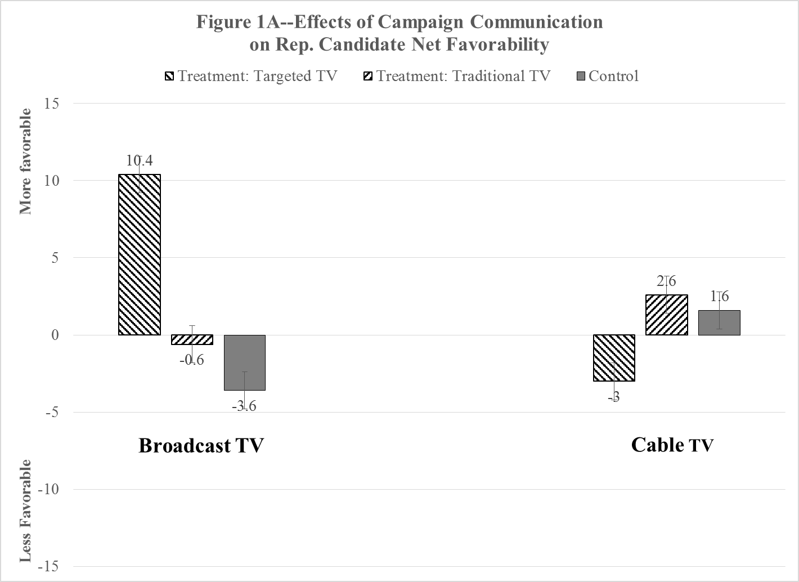
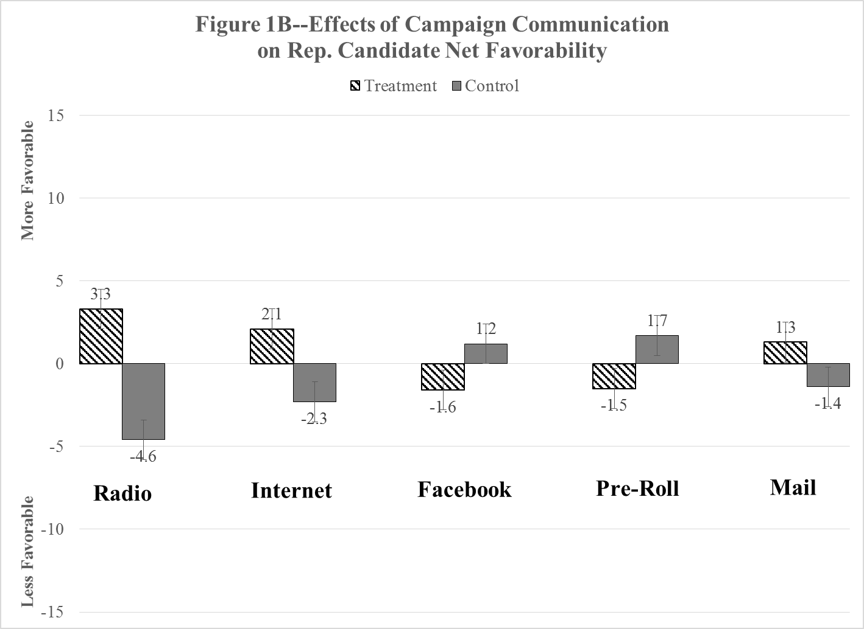
Notes: Point estimates reflect the difference between the baseline estimate of net favorability for Abbott (+28.8) and the net favorability observed for the group (treatment or control) in the post-election survey (N=2,968). The estimates are based on multiple classificatory analysis, which controls for factors and covariates such as age and strength of Republican partisanship.
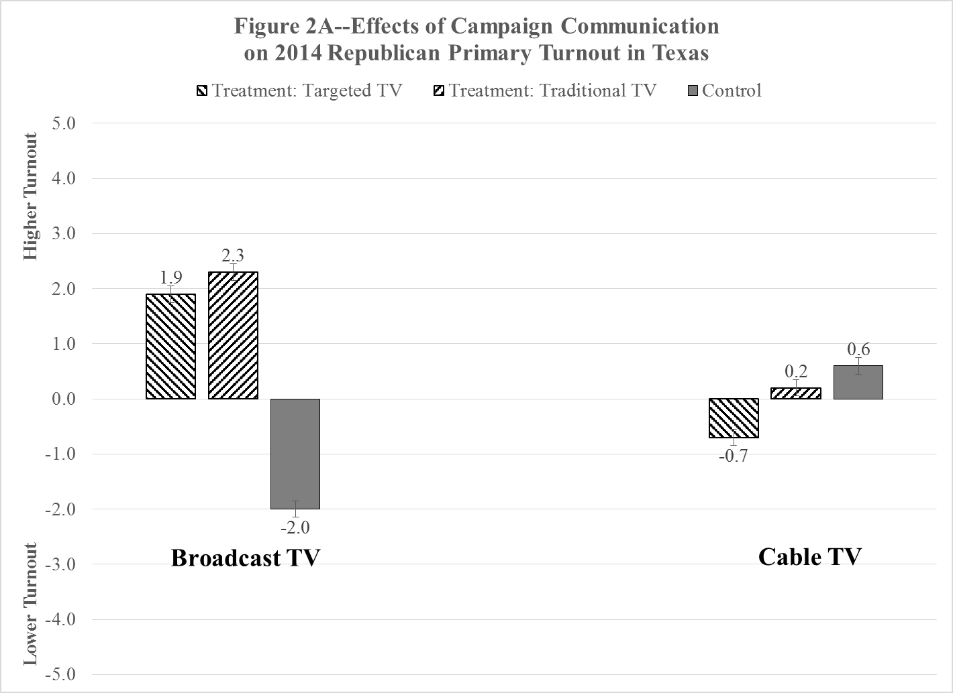
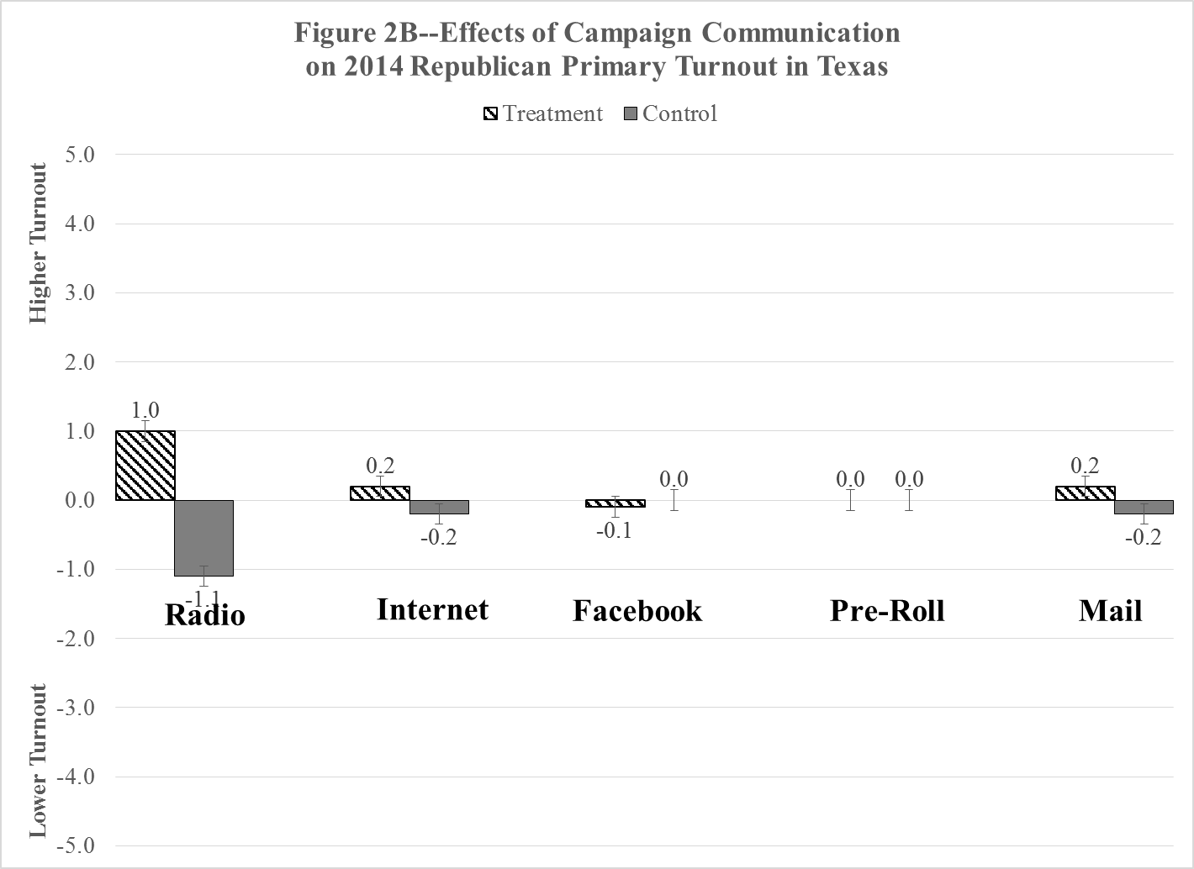
Notes: Point estimates reflect the difference between the baseline estimate of Republican turnout and the actual turnout rate observed for the group (treatment or control) in the post-election voter file (N=@1.1 million). The estimates are based on multiple classificatory analysis, which controls for factors and covariates such as age and strength of Republican partisanship.

Figure 3—Effects of Campaign Communication
on Candidate Favorability and 2014 Texas Republican Primary Turnout

Notes: Plotted points represent the “difference from baseline” estimates derived from the MCA for treated and untreated groups on two dimensions: (1) net favorability towards Greg Abbott and (2) 2014 Texas Republican primary turnout. Campaign effects are suggested by two comparisons. First, the distance between the treated and untreated points: the greater the distance, the greater the treatment/campaign effect. Second, the distance between the treated point and the origin/baseline. Points close to the origin point (0, 0) indicate minimal campaign effects. The estimated “total” effect of the campaign mode increases as points move towards the upper-right quadrant.

Notes: Plotted points represent the “difference from baseline” estimates derived from the MCA for treated and untreated groups on two dimensions: (1) net favorability towards Abbott and (2) Republican primary turnout. As in the previous figure, campaign effects are suggested by two comparisons: the distance between the treatment and non-treatment points, and the distance between the treatment point and the origin/baseline.

Notes: Plotted points represent the “difference from baseline” estimates derived from the MCA for treated and untreated groups on two dimensions: (1) net favorability towards Abbott and (2) Republican primary turnout. Here, campaign effects are suggested by the distance between the treatment point and the origin/baseline.

References
Ansolabehere, Stephen, & Shanto Iyengar. 1996. Going Negative. New York, NY: Free Press.
Campbell, James. 2008. The American Campaign. 2nd edition. Texas A&M Press.
Cardy, Emily A. 2005. “The Persuasion Effects of Partisan Direct Mail and Phone Calls.” Annals of the American Academy of Political and Social Science, 601 (1): 28-40.
Chang, Chingching. 2003. “Party Bias in Political-Advertising Processing.” Journal of Advertising, 32 (summer): 55–67.
Decker, Steffi, & Josh Koster. 2014. “Five Digital Mistakes to Avoid.” Campaigns and Elections, September 15, 2014: 16-18.
Druckman, James. 2004. “Political Preference Formation: Competition, Deliberation, and the (Ir)relevance of Framing Effects.” American Political Science Review, 98 (4): 671-686.
Enos, Ryan, & Anthony Fowler, 2016. “Aggregate Effects of Large-Scale Campaigns on Voter Turnout.” Political Science Research and Methods, FirstView article (April 2016): 1-19.
Fieldhouse, Edward, David Cutts, Paul Widdop, and Peter John. 2013. "Do impersonal mobilisation methods work? Evidence from a nationwide Get-Out-the-Vote experiment in England." Electoral Studies, 32 (1): 113-123.
Fiorina, Morris. 2010. Culture Wars: The Myth of a Polarized America (3d edition). New York, NY: Longman.
Fowler, Erica, & Travis Ridout. 2014. “Political Advertising in 2014: The Year of the Outside Group.” The Forum, 12 (4): 663-684.
Gerber, Alan S., & Donald P. Green. 2004. Get Out the Vote! Brookings Press.
Gerber, Alan, Donald Green, James Gimpel, & Daron Shaw. 2010. “How Large and Long-lasting are the Persuasive Effects of Television Campaign Ads? Results from a Randomized Field Experiment.” American Political Science Review, 105 (1): 135-150.
Green, Donald, & Jonathan Krasno. 1990. “Rebuttal to Jacobson’s ‘New Evidence for Old Arguments’.” American Journal of Political Science, 34 (2): 363-372.
Hersh, Eitan, & Brian F. Schaffner. 2013. “Targeted Campaign Appeals and the Value of Ambiguity.” Journal of Politics, 75 (2): 520-534.
Hillygus, D. Sunshine, & Simon Jackman. 2003. “Voter Decision Making in Election 2000: Campaign Effects, Partisan Activation, and the Clinton Legacy.” American Journal of Political Science, 47 (4): 583-596.
Huber, Gregory A. & Kevin Arceneaux. 2007. “Identifying the Persuasive Effects of Presidential Advertising.” American Journal of Political Science, 51(4): 957-977.
Issenberg, Sasha. 2012. The Victory Lab. New York, NY: Random House.
Iyengar, Shanto, and Adam Simon. 2000. “New Perspectives and Evidence on Political Communication and Campaign Effects.” Annual Review of Psychology, 2000, 51:149- 169.
Iyengar, Shanto, & Sean Westwood. 2015. “Fear and Loathing across Party Lines: New Evidence on Group Polarization.” American Journal of Political Science, 59 (3): 690-707.
Krasno, Jonathan, & Donald Green. 2008. “Do Televised Presidential Ads Increase Voter Turnout? Evidence from a Natural Experiment.” Journal of Politics, 70 (1): 245-261.
Pfau, Michael, R. Lance Holbert, Erin Szabo, & Kelly Kaminski. 2002. “Issue-Advocacy Versus Candidate Advertising: Effects on Candidate Preferences and Democratic Process.” Journal of Communication, 52 (2): 301-315.
Ridout, Travis, & Michael Franz. 2011. The Persuasive Power of Campaign Advertising. Philadelphia, PA: Temple University Press.
Shaw, Daron R. 2006. The Race to 270. University of Chicago Press.
Zaller, John, 1992. The Nature and Origins of Mass Opinion. Cambridge University Press.

We use these terms interchangeably since campaign modes that are repeat a message many times also tend to aim these messages at wide audiences.
Some contend that highly aware citizens are the most likely to be affected by political messages. But most of these consider news messages, not political advertising, and focus on the activation of issues used to evaluate the candidates (“priming”) as opposed to persuasion (e.g., Druckman, 2004).
The Davis campaign raised $24 million and received another $13 million from Texas Victory Committee, a joint effort between her campaign and Battleground Texas. Abbott spent $47 million.
Due to some earlier research we had conducted, we were invited to attend this meeting.
We excluded other media markets from the study because they are either too small (Victoria and Laredo) or are primarily located in another state with only partial spill-over into Texas (Sherman-Ada and Shreveport).
The design follows Gerber, et al. (2010). A table showing treatment-control assignments, by outreach mode, for every Texas media market is presented in the supplemental appendix.
This is the equivalent of every targeted voter seeing the ad, on average, six times per week.
All ads and direct mail pieces are available in our supplemental materials.
Cable zones in Texas line up very closely to zip codes, allowing us to easily translate matched zip codes into cable zones for treatments. The cable TV portion of the field experiment purposefully set aside excluded markets (Dallas-Ft. Worth, Houston, San Antonio, and Austin) and control markets (Amarillo, El Paso, Wichita Falls, and Tyler).
The online ads’ references to Davis were minimal. The suggested link was to a positive Abbott ad.
Scores estimating turnout likelihood and favorability towards Abbott were based on micro-targeting models using past voting behavior, participation in a partisan primary, length of residence at current location, gender, age, race, ethnicity, marital status, and inferred issue preferences.
The pre-election survey was conducted on February 7-11, 2014, prior to the February 12 experiment launch date. The post-election survey was conducted on March 5-12, after the March 4 election. The response rates are relatively high compared to typical statewide survey due to the higher level of interest and engagement of likely primary voters. The absence of a cell phone supplement did not appreciably affect the unweighted results, probably because the targeted population here resembles the landline population. The survey results are available in our supplemental materials. One of the “no campaign” control markets, Wichita Falls, was mistakenly omitted from the phone survey universe. This limits our ability to estimate effects from “matched” comparisons in the Wichita Falls cluster, although we can use individuals from other “no campaign” control markets—balanced with appropriate covariates—to estimate effects.
Although MCA assumptions are supported by an examination of the preliminary data, we experimented with alternative estimators, including ordered probit and multinomial logit. The significance of the estimated coefficients was strikingly similar across the estimators.
The results of these randomization tests, as well as the full ANOVA/MCA models, are available in our supplemental materials.
For simplicity’s sake, we refer to “voters” rather than “Abbott’s top fifty percent.”
When we refer to “persuasion” in the analysis we are (strictly speaking) referring to changes in favorability towards Abbott, which is closely related to the vote (Shaw, 2006).
In addition, the test of Facebook advertising was further limited to those who expressed an interest in Abbott.

