Does Information about Campaign Contributions Influence Vote Choice?

Abstract
Using the results from experiments embedded in two national surveys, this paper tests voters’ reaction to the amount and source of campaign contributions. We find that voters’ candidate preferences change far more in reaction to information about the source than to the amount of a candidate’s campaign contributions. Furthermore, the data indicate that the influence of contribution sources is more likely to affect support for Democratic and independent candidates.

At the heart of the Supreme Court’s argument in favor of campaign finance disclosure, articulated most fully in its Buckley v. Valeo (1976) decision, is the conviction that the informational value to voters of disclosed campaign finance information trumps valid concerns over chilled speech. Specifically, the Court—in a curious nod to the spatial theory of voting (Downs 1957)—asserted that such information, “... allows voters to place each candidate in the political spectrum more precisely than is often possible solely on the basis of party labels and campaign speeches.” In other words, campaign finance information is alleged to provide voters with critical information about candidates beyond knowing their party affiliations and policy positions. It is only recently that scholars have begun to test aspects of this strong empirical claim by the Court (Sances 2013; Dowling and Miller 2014).
This paper presents the results of survey-based experiments testing the impact of campaign finance information on the candidate preferences of survey respondents. We find that candidate support does vary with some, but not all, types of campaign finance information. In particular, we present evidence that it is mainly information about the source, not the amount, of contributions that most influences voter preferences. This finding represents a significant contribution in light of the surprising fact that the comparative impact of information on contribution source and amount has never been established empirically. In addition, our results show that voters react more to revelations about the source of contributions to Democratic and independent candidates than to Republicans, suggesting that fundraising details must provide “new” information if they are to prompt voters to update their vote choice. Collectively, these findings add to our understanding of how voters process campaign finance information and what that might suggest for campaign finance reform.

Disclosure and the Courts
The disclosure of campaign finance activity was one of the main points of early federal campaign finance laws. These reforms were part of concerted Progressive Era efforts to address growing concerns about the corrupting influence of money in politics. The first disclosure bill was introduced in 1906 under pressure and guidance from the National Publicity Bill Organization, a private group organized by Perry Belmont, a leading reformer, to galvanize grassroots support for disclosure of the flow of money in politics. Although this first bill, introduced by Samuel McCall (R-MA), failed, subsequent efforts in 1910 (c.392, 36 Stat. 822) and again in 1911 (§ 2, 37 Stat. 26) brought to life the first meaningful federal campaign finance disclosure laws (Mutch 1988, pp. 8-16).
Constitutional questions have surrounded campaign finance laws from the beginning. However, it was not until the 1976 Buckley v. Valeo decision that the Supreme Court directly addressed the issue. Such laws were challenged as part of a broad First Amendment-based assault on the 1974 amendments to the Federal Election Campaign Act (FECA), on the grounds that disclosure has a chilling effect on political speech. The Supreme Court ruled that the FECA disclosure rules were entirely constitutional, in part because they provide for the dissemination of valuable information to voters about the ideology of candidates – their place on the “political spectrum” – and thus facilitate more informed voting decisions.
This presumed link—which underpins much of the Court’s thinking about legitimate limits on protected political speech and, consequently, campaign finance regulation—has very rarely been subject to empirical examination. In this paper we test the Court’s voter information argument, examining whether the candidate preferences of survey respondents are influenced by specific information about campaign contributions to a hypothetical candidate. In what follows, we draw on information theories to develop and test expectations about the sensitivity of the American public to revelation of campaign contribution information.

Campaign Contributions in the Public's Eyes
We begin with some intuitive theoretical assumptions about uncertainty, information, public opinion and democratic processes. For illustrative purposes, and because we ultimately wish to focus our study on voters’ preferences, we frame this discussion in terms of candidates and voting rather than issues and policy positions. As election campaigns unfold, we assume that voters “update” their attitude towards a candidate based on low cost, easily available information such as a candidate’s party and whether the candidate is the incumbent office-holder (Lodge et al. 1995), as well as other heuristics (Tversky and Kahneman 1974; Popkin 1991; Lupia 1994).We further assume that information about a candidate’s friends, supporters, and contributors is best understood as a heuristic; it provides voters with a low-cost basis for developing impressions about the candidate and what she will do if elected.
Based on this perspective, what the Supreme Court contends is that campaign finance information (e.g., information about how much and from whom a candidate has raised money) could affect voters’ candidate preferences, or even their decisions to vote at all. The underlying logic of the Court ought to be directly observable in how people react to information about a candidate’s campaign funding. In particular, information about the amount and source of a candidate’s campaign contributions should influence support for the candidate.
The direction of influence is not obvious. With respect to contribution amounts, a candidate receiving tens of millions of dollars in contributions may be viewed more favorably to the extent this demonstrates broad support. Conversely, she may be viewed less favorably because she is allied with moneyed interests. With respect to contribution sources, money flowing from a particular group could increase support by signaling a connection with a preferred cause. Or, it could decrease support by signaling a connection with a despised interest.
In setting our sights on voters and candidates, we draw on (and seek to bolster) the voluminous literature on voting in the U.S. We know, for example, that voters rely on party identification to infer things about candidates—their issue positions (Campbell et al. 1960; Lewis-Beck et al. 2008) and their personal traits (Hayes 2006). It follows that voters may also infer that candidates from one party are more likely to raise substantial amounts of money or to collect contributions from certain sources. In this way, actual information about contributions may already have been factored into their likelihood of voting for a candidate. We also know that information contrary to one’s partisan leanings (say, for example, that your party’s candidate has accepted major contributions from a disreputable source) is often discounted or rationalized so as to avoid cognitive dissonance—a phenomenon often referred to as “motivated reasoning” (Taber and Lodge 2006; Redlawsk, Civittini, and Emmerson 2010; but see Bullock 2009). All of this may be why we have little direct evidence on the impact of campaign finance information; the conventional wisdom in the voting literature is that information about campaign contributions is unlikely to be noticed by voters (see Delli Carpini and Keeter 1996) and, contrary to the Court’s assumptions, unlikely to move voters even if they encounter it.

The Survey Experiment
From a design stand-point, we wish to develop an empirical study that allows us to estimate the impact of various sorts of campaign contribution information on voting behavior. A direct tack would be to conduct a survey and ask people how such information affects them; however, such an approach raises obvious questions about the reliability of self-reported reactions. Instead, like both Sances (2013) and Dowling and Miller (2014), we chose to embed an experiment within a survey to test information effects directly.
Our design differs in critical ways from these recent efforts, however. Unlike Sances (2013), we focus on information related to the source and size of contributions to candidates, which speaks to money directly collected and spent by a candidate, rather than the identity of independent supporters. Unlike Dowling and Miller (2014), we 1) focus on the relative effects of contributions from different interest groups (rather than comparing self-funded versus non-self-funded candidates), 2) specifically identify interest groups by name or category, and 3) manipulate the contribution amounts.

Survey Description
For this study we conducted two nationally representative surveys—one in October of 2009 (before the 2010 Citizens United decision) and one in October of 2013 (roughly three and a half years afterwards). The October 2009 survey was conducted online by YouGov and included 2,100 respondents. The survey instrument focused exclusively on attitudes towards money and politics. Embedded within the instrument was a randomized experiment designed to gauge respondents’ likelihood of voting for a hypothetical U.S. Senate candidate (the generic “Chris Jones”). Three informational treatment variables were manipulated: the amount of money raised by the candidate ($50,000 versus $20 million), the main source of campaign contributions (friends and acquaintances versus tobacco companies versus trial lawyers), and the candidate’s party affiliation (Democrat versus Republican versus independent).
The October 2013 survey was also conducted online by YouGov and included 2,000 respondents. We followed the 2009 survey design and embedded a randomized experiment within the survey; this one also sought to gauge respondents’ likelihood of voting for Chris Jones. But while we repeated the contribution amount treatment, we tested a different set of contributors. In place of tobacco companies and trial lawyers, we substituted oil companies and green energy companies. The logic and particulars of each treatment manipulation are delineated below.

Contribution Amount
Although federal campaign finance laws limit the amount of contributions to individual candidates from individuals and political committees, they do not limit the amount of money that a congressional candidate can raise or spend. To test the effect of the size of aggregate contributions raised by a candidate on the political behavior of voters, we randomly assign survey respondents to one of two treatments. In the first treatment, respondents are informed that a candidate for office has raised, in total, $50 thousand ($50K); in the second, they are informed that he has raised $20 million ($20M). The idea is to expose respondents to extremes – the “high end” and “low end” contribution amounts a Senate candidate is likely to raise – and to see how they react. These specific numbers were derived from responses in our pilot surveys to questions about how much money voters thought was coming from major contributors—we wanted our treatments to be significantly above and below the average and median response.
Based on the Court’s logic, respondents should recoil from a candidate raising $20M from a clearly identified source or interest; they might support the other candidate or they might stay home, but they should be less likely to support the well-heeled candidate. From our perspective—again, based on generalizations from information theory and public opinion research—voter reactions could go in different directions. Given what we know about Americans’ cynicism towards our politicians (Delli Carpini and Keeter 1996), there could very well be no reaction whatsoever. If there is a reaction, though, our expectation is that it could go either way. On the one hand, the amount raised from any one particular class of contributors could evoke concerns about political indebtedness – the quid pro quo that so concerns the Court – and cause voters to take their support elsewhere. On the other hand, the ability to raise a substantial amount of money may signal candidate strength and appeal to voters seeking affiliation with a resourceful winner or fellow ideological traveler.

Contribution Source
As with contribution amount, our goal with the October 2009 experiment was to offer respondents relatively extreme treatments. That is, the information conveyed in the treatment had to be strong enough to provoke (potentially, at least) a reaction without straining credulity. In the case of possible sources of campaign contributions, there was no shortage of provocative characters from which to draw. After much debate, we settled on three primary sources of contributions to our fictitious Mr. Jones—friends and acquaintances, tobacco companies, or trial lawyers.
The first of these – a network of friends – arguably represents the least provocative source of support (so long as they’re not identifiable as a bunch of Wall Street bankers...). Conversely, tobacco companies represent a group embroiled in considerable controversy, particularly in the judgment of liberals and Democrats. Trial lawyers have a similarly poor reputation (though perhaps not quite so bad), held in particular distain by conservatives and Republicans. Thus, two of our treatment groups are designed to provoke negative reactions, with the potential for a differential partisan effect as Republicans and Democrats selectively search for heuristics to aid their vote choice (Bonica 2013; Lupia 1994; Popkin 1991). If voters are prepared to forgive “friendly” third-party contributions, then we might expect, for instance, a Democratic candidate to be punished relatively less for receiving lawyer rather than tobacco money.
Again, information theory and the more generalized research on political opinion suggest that this information could very well have little to no effect on voters’ behavior. Conversely, it is also possible that we will see something consistent with campaign finance reform rhetoric, which places information about corporate money in a class of its own, as the most likely to elicit the greatest negative voter response. This would be followed by a slightly less vehement reaction to trial lawyers’ contributions, though reactions could vary depending upon both the party of the candidate, as well as the partisanship of the respondent. Finally, the least backlash—and perhaps even a slightly positive reaction—would be expected to a candidate acquiring campaign funds from friends and acquaintances.
In designing the 2013 study, we opted to update and expand the range of contribution sources; the aggregate contribution treatment was unchanged from the 2009 experiment. First, we think that tobacco companies and trial lawyers were less relevant in 2013 than they may have been in 2009. Second, while these entities served our initial purpose of measuring how potentially controversial contribution sources influence the attitudes of respondents, they could be too unusual to allow us to generalize. So for 2013 we used oil companies and green energy companies, along with friends and acquaintances, as the treatments. Arguably, Democrats are relatively unfavorable towards oil companies, while Republicans are relatively unfavorable towards green energy companies.
If there is a negative contribution source effect on attitudes towards Mr. Jones, we expect it to be greatest in response to oil company contributions given the combination of big business and an eco-unfriendly reputation. Green energy companies, on the other hand, provide a mixed prompt—Republicans may recoil at stories of cronyism (e.g., Solyndra) and other government subsidized boondoggles, but Democrats and independents may temper their concerns about corporate money given the positive social message of such enterprise. At any rate, these stimuli add range to what we can say about contribution source effects based on the 2009 experiment.

Partisanship
We are interested in the underlying support for Democratic, Republican, and independent candidates, and (more particularly) in how voters react to information about campaign contributions going to a candidate of a specific party. The experiment therefore randomly varies the party of Mr. Jones, allowing us to gauge 1) how voters react to candidate partisanship, and 2) how candidate partisanship influences the impact of specific information on campaign contributions on the voting decision.
In addition to the impact of candidate party affiliation, we are interested in the effect of voter party identification. In particular, how do partisans react to campaign contribution information about their “own” candidate versus the “other” candidate? And how do independent voters react to campaign contribution information about partisan candidates? So while we are theoretically interested in how partisans react to contribution information about out-party candidates, we expect support to be low across-the-board and are more interested in whether such information affects how they view in-party candidates. Similarly, as a practical matter we are relatively less interested in reactions by voters to the (rare) independent candidate; we want to know how independents react to contribution information about the major party candidates. More generally, we think this focus—and the attendant estimated effects—will yield important and practical insight with respect to mobilization and persuasion.
On the crucial question of how partisanship interacts with campaign contribution information, we expect that the extreme treatment—$20M from tobacco companies/trial lawyers—could be less damaging for partisan candidates than for independent candidates. Partisan candidates may be assumed to be “in bed” with their respective moneyed interests, such that information conveyed by the treatment may not be “new” and may, in fact, already have been factored into the vote choice. Republican candidates, in particular, may be relatively immune to disclosure given their ties to business and moneyed interests compared to Democratic candidates (Herrnson 2009).

The Experimental Frame
The actual experiments embedded in the larger surveys entailed having respondents read and react to a slightly doctored news story in which the electoral prospects of a hypothetical U.S. Senate candidate – Chris Jones – are discussed. Here is an abbreviated version of the story used for the 2009 experiment (items in brackets are randomly assigned to respondents):
“WASHINGTON, D.C. — When it comes to next year's primaries for U.S. senators, a few challengers may get lucky as their opponent incumbents are feeling a lot like Rodney Dangerfield: They can't get any respect…As a(n) [Independent / Republican / Democrat], Chris Jones hopes to take advantage of the current political climate to win a Senate seat in November 2010. If his fundraising is any indication, his chances seem pretty good so far. Since last December, Jones has raised [$20 million / $50,000], with the majority of this money coming from [the tobacco industry / trial lawyers / friends and acquaintances]. Jones may get lucky, if the transcending trend of his popularity and fundraising keeps up. Over the next year, Jones will rely more and more on his staff and growing army of volunteers to launch his campaign with an eye toward an eventual victory in November 2010.”
For 2013, the article was slightly updated and streamlined, with oil companies and green energy replacing the tobacco industry and trial lawyers. Note that we have constructed a 3 x 2 x 3 design; respondents were randomly assigned into one of 18 treatment cells (see online appendix for detailed information on cell sizes). For a relatively small-N survey, this design would be problematic, as the number of respondents in the different treatment cells would be too small to assume the random distribution of important covariates or to generate statistically significant differences. But our surveys of 2,100 in 2009 and 2,000 in 2013 produced 1,606 and 1,950 valid responses (respectively), with an average of 89 and 108 responses per cell, obviating both of these concerns.
Note also that we do not have a traditional control group, as it is counter-productive to ask about the likelihood of voting for Chris Jones without offering any information about the candidate. Rather, we follow common experimental practice (Gadarian and Albertson 2014) and use the most innocuous of treatments—independent candidate, $50K raised, contributions primarily from friends and acquaintances—as our baseline.
Following the news story, respondents were asked to rate the likelihood of voting for Chris Jones on a 0-10 scale. This number serves as the key dependent variable in our analysis. Focusing on this particular dependent variable is not as obvious a choice as one might think. While we are ultimately interested in whether (and to what extent) information about campaign contributions affects vote choice, we might also have focused on whether such information affects voters’ perceptions of corruption or systemic efficacy, or whether it affects voters’ ability to place the candidates on an ideological scale. These are, after all, assertions implicit in the Court’s previous holdings. Moreover, we use a scaled measure of perceived corruption as an independent variable in predicting vote choice in our multi-variate models. Ultimately, however, our emphasis on vote choice is a matter of theoretical and practical necessity. Theoretically, we want to know about the behavioral impact of contribution information; opinions, especially those aimed at the election system, are much less interesting if they do not result in action. Practically, voters already express substantial cynicism towards the financing of elections in the U.S. It is unclear whether a treatment that moves self-rated cynicism from, say, 80 percent to 90 percent will register as either statistically or substantively significant. Still, we acknowledge that our choice here means we are left to assume, rather than test, some interesting causal mechanisms.

Campaign Contribution Information and Vote Preference
A First Cut
Contribution source matters (see Table 1). Chris Jones receives his highest support when raising most of his money from friends and acquaintances. His support drops, by statistically significant margins, if he received contributions from the tobacco industry, trial lawyers, or (in the 2013 survey) the oil industry. Interestingly, the consequences of raising money from green energy sources (2013) are statistically indistinguishable from those of friends and acquaintances.
Conversely, contribution amount does not matter. In both the 2009 and 2013 experiments, support for candidate Jones is unaffected by the amount of money he receives.
The partisanship of the candidate also matters. In 2009, Jones does worse if he is identified as a Democrat regardless of contribution source and amount (his average support as a Democrat is 3.58, compared to 4.27 as a Republican and 3.99 as an independent). This difference is statistically significant and almost certainly reflects the mood of the nation at the time of the survey; in the fall of 2009 Republicans and independents were energized (and angry) while Democrats were divided and defensive over issues such as the auto industry bailouts and health care reform. Still, the pro-GOP edge is striking and perhaps prescient in light of the Republican electoral victories of 2009 and 2010. This Republican advantage disappears in the 2013 survey, which may reflect the public’s frustration with the two major parties due to partisan stalemates over the federal budget and debt ceiling.
[Table 1 about here]

A Closer Look: Are there Differences by the Candidate’s Party?
Figure 1 displays the mean support for candidate Chris Jones by contribution source, amount, and his party. The 2009 data demonstrate that contribution source has a clear and consistent effect on the likelihood of supporting Jones. When the candidate received most of his financial support from friends and acquaintances, Jones always scores higher than when he garners contributions from either trial lawyers or tobacco companies, regardless of his party affiliation. When candidate party affiliation is factored in, however, we find differential effects. A Republican Jones, for instance, obtains higher support when he receives donations from sources tied to the tobacco industry than to trial lawyers; the opposite is true for a Democratic Jones, for whom tobacco money does the most damage.
[Figure 1 about here]
In contrast to the source effects, differences in contribution amount do not much affect candidate support. Across six such comparisons (where only contribution amount varies), we observe no statistically significant differences.
It is also worth noting that contribution information seems to have a greater impact on a Democratic (as opposed to a Republican) Jones. Contributions from friends and acquaintances produce a significantly higher level of candidate support across the different amount of contributions for the Democratic candidate (p<0.5), but such a difference is found for the Republican candidate only between the friends and acquaintances and trial lawyers only in the $50K condition. This suggests that information about campaign contributions doesn’t provide voters with as much new, relevant information about Republican candidates as it does for Democratic candidates, particularly in a big-money race.
The 2013 data in Figure 1 add a layer of subtlety to the story. While the oil industry is overall the least favored of the three funding sources (see Table 1), the magnitude of the effect depends on the candidate’s party and, to a lesser degree, contribution amount. For a Republican Jones there is no statistically significant difference among the different contribution sources regardless of the contribution amount. By contrast, the source effect under the $50K condition can be clearly observed for Democrat Jones, whose average support score in the oil industry condition (3.55) is significantly lower than in the green energy (4.79) and the friends and acquaintances (4.34) conditions (p <0.01). When we move to the $20M condition, the source does not make a statistically significant effect on the level of candidate support (p=0.35). What is the most noticeable, however, is the large drop when the big money comes from green energy companies—33 percent (from 4.79 to 3.19). This decline is the largest across all experiment conditions in the 2013 survey. Why such a powerful negative reaction? Perhaps a $50K contribution suggests a conventional link between the party and its pro-environmental agenda, thus boosting the candidate support, while a $20M contribution indicates excess and corruption. This effect, however, is only for the Democratic candidate—when Republican Jones gets $20M in contributions from green energy companies, he does only slightly less well than in the $50K condition.
In sum, we can conclude that in general the contribution source rather than the amount makes a difference in voters’ decision making with the exception of the large donations from green energy industry to a Democratic candidate. In addition, the candidate’s party also conditions the effect of campaign finance information. The results rather clearly show that contribution source effects are generally larger for a Democratic candidate than for a Republican counterpart.

Are there Differences by Respondents’ Partisanship?
One possibility discussed earlier that we have not yet explored is that the party identification of voters shapes their response to information about contribution source and amount. We know partisans are likely to reject the out-party candidate, so a critical question is whether campaign contribution information affects the enthusiasm of partisans for their own candidate. The other important question is whether (and how) independent voters are influenced by contribution information about Democratic and Republican candidates. In light of this, we re-sort the results of the experiment, separating respondents by their party identification. Collectively, our data analysis shows the continued and powerful effects of party on voter decision-making.
In Figures 2A and 2B, we segment the experimental treatments by respondent party identification. We find a strong and consistent tendency for voters to reject a candidate from the other side of the partisan aisle; they are therefore relatively unaffected by information about campaign contribution source or amount. Voters do respond to information about their own party’s candidate, however, as both Democrats and Republicans are more likely to support in-party candidates when those candidates receive campaign contributions from friends and acquaintances.
As shown in Figure 2A, the 2009 experiment results tell us that Republican respondents are much more likely to support Republican Jones than Democrat Jones. They also prefer friends and acquaintances to the other two contribution sources, while favoring trial lawyers the least. Yet, the size of the source effects depends on the candidate’s party and contribution amount. In the case of a Republican candidate, when the contribution amount is $50K, their preference for friends and acquaintances over trial lawyers is statistically significant (p<0.01), while their preference for friends and acquaintances over the tobacco industry is not. When evaluating a Democratic candidate, typically neither source nor amount has a significant effect on the support level. Note, however, that a large contribution from the least favored group—trial lawyers—does reduce the level of support significantly Democratic respondents’ most preferred funding source is friends and acquaintances and the least preferred is the tobacco industry. The differences in support by funding sources are significant for a Democratic Jones (p< 0.05). Overall, Democrats do not seem to factor in campaign finance information about the other side’s candidate, while they do so for their own.
It is intriguing to observe that a candidate’s party does condition how independent voters view information about campaign contributions. Earlier in the study, we suggested this might be the case. Independents are much less likely to support a Democratic Jones receiving money from either trial lawyers or tobacco companies (p<0.05). By contrast, independent voters are almost completely unaffected by contribution source when considering a Republican Jones. Furthermore, as with partisans, contribution amount does not have any substantial influence on independents.
[Figure 2A about here]
Looking at the 2013 experiment (Figure 2B), we again witness partisan differences in evaluating campaign finance information. In general, Republican respondents (as in 2009) are most supportive of a candidate who receives contributions from friends and acquaintances, and are least supportive of a candidate who receives contributions from the green energy industry. With the exception of the $20M/green energy condition, Republican respondents do not show differences in support for a Democratic Jones by contribution source, however, whereas they are differentially predisposed towards a Republican Jones (contributions from friends and acquaintances are preferred to those from oil companies, p< 0.1; oil company contributions are preferred to those from green energy, p< 0.01).
Democrats prefer green energy companies over other funding sources, irrespective of Jones’ party. The only instance in which they favor another funding source (friends and acquaintances) is for Democrat Jones at the $20M mark. By contrast, their preference for friends and acquaintances over the oil industry is only significant for Democrat Jones; this tendency is decidedly insignificant for Republican Jones.
Similar to Democrats, independents are less likely to support candidates who draw money from oil companies, while being equally supportive of candidates who gather money from green energy companies or friends and acquaintances. When considering a Republican candidate, the funding source does not matter. A somewhat greater effect is found for Democrat Jones (p< 0.07), although this effect is driven by the disdain of independent voters for lower level contributions from the oil companies. While the contribution amount in general does not make a difference in independents’ evaluation of Jones, independent voters join their Republican and Democratic counter-parts in disliking Democratic candidates who get $20M from green energy companies. The difference in means in the $20mil and $50K conditions for the green energy contribution to the Democratic candidate is also statistically significant at p=0.01.
The findings in Figures 2A and 2B are in general consistent with our expectations. Campaign finance information concerning an in-party candidate provides more meaningful cues to party identifiers, while independent voters consider it more seriously when they evaluate a Democratic candidate than a Republican. The large sum of contribution to a Democratic candidate from the green energy industry, on the other hand, raises a red flag across the partisan spectrum.
[Figure 2B about here]

Multivariate Tests
Although simple means comparison tests are highly instructive, we need to ensure that the effects noted above are not influenced by systematic differences in assignment to treatment groups. As Imai (2005) notes, random assignment does not necessarily eliminate the possibility that estimated effects are driven by demographic or attitudinal variance between and amongst cell populations. To control for this possibility and to specify conditional effects, we offer multivariate models of support for candidate Jones.
Given our continuous measure and the plausibility of I.I.A. assumptions, we use an ordinary least squares estimator to analyze the effects of our identified factors on support probability. The dependent variable is the 0-10 level of support for Jones, our hypothetical U.S. Senate candidate. Our key independent variables include the source and amount of contributions to Jones, along with Jones’s party. In addition, we control for a range of political and demographic variables that—were they not randomly distributed—might account for variation in vote intention. More specifically, we offer controls for the respondent’s party identification (Republican, independent, and Democrat), age, education, income, union household status (2009 only), gender, and general political knowledge. Importantly, we estimate separate models for Republican, Democratic, and independent respondents. Finally, we also add a composite index of the respondents’ perception of corruption in politics, with which we can test the Court’s assumption that such a perception might influence voting behavior.
Table 2 focuses on 2009 and offers the regression estimates of the base and full models with all respondents, Republicans, Democrats, and independents, respectively. Notice that the full models include multiplicative interaction terms for contribution source and the candidate’s party. Other potential interactive relationships were estimated (including those between the candidate’s party and contribution amount, and between contribution source and amount), but none proved significant. We also included the 3-way interaction term for contribution from trial lawyers, contribution amount, and a Democratic candidate, to account for the preliminary finding that the mean difference between $50K and $20Mil contributions from trial lawyers to a Democratic candidate is significant among Republican respondents (this finding is confirmed by the multivariate model).
The interaction coefficients should be judged against the baseline category: Jones is an independent candidate who has received $50K from friends and acquaintances. For the three-way interaction term, the baseline category is slightly different: it would be a non-Democratic candidate who has received $50K from the tobacco industry or friends and acquaintances.
In examining the models in Table 2, we note that only one of the control variables—the respondent’s identification as a Democrat—has any influence on the probability of supporting Jones. This persists even when controlling for different treatments. Perceptions of corruption (another attitude) also exert a statistically significant influence on support even after controlling for different treatments. Put plainly, those who think the system is corrupt are less likely to support Jones. These results, in addition to other checks of randomization in the assignment of treatments, strongly indicate that the experimental design “worked.”
The models also reinforce our earlier results: candidate support is not influenced by contribution amounts. However, as suggested earlier, the source of campaign contributions exerts a significant impact: compared to contributions made by friends and acquaintances, those from the tobacco industry or trial lawyers decrease the likelihood of supporting Jones. For example, campaign donations to Jones from tobacco companies decrease the likelihood of voting for him by almost one point on a 0-10 scale, holding other factors constant. A similar but slightly lesser effect is found in the case of trial lawyers.
As for the candidate’s partisanship, we again find that when Jones was presented as a Republican candidate, the vote probability score is significantly greater than when he is an independent or a Democrat, even controlling for the respondent’s party identification. The data here clearly foretell subsequent GOP triumphs in Virginia, New Jersey, and Massachusetts, where Democratic candidates were swamped by an energized GOP base and disgruntled independent voters in November 2009 and January 2010 (respectively).
What of the interactive relationship between the candidate’s party and contributions? Results of the full model show that the candidate’s partisanship does indeed change the relative importance of funding sources in the vote decision. More specifically, the interaction effect is statistically significant when Jones is identified as a GOP candidate and contributions come from the tobacco industry. Furthermore, in this instance (when Jones is identified as a Republican), the overall effect associated with contribution source disappears. All of this means that when the candidate is Republican, the negative effects associated with campaign contributions from the tobacco industry and trial lawyers (to a lesser degree) decline. When the candidate is Democratic, the negative effect of tobacco contributions is reduced in comparison with an independent candidate, but they still decrease his support.
These findings suggest that when Jones is labeled as independent, the contribution source effect is largest. Indeed, these regression results show that Republican candidates are relatively immune to negative blow-back from financial connections with corporations or special interest groups. The public's expectations seem to be that independent and (to a lesser extent) Democratic candidates are less tied to corporate interests so that information establishing such a connection has a more dramatic influence on voters’ appraisals. Conversely, voters are in general more tolerant of the Republican Party regarding the potential influence of corporate or special interest groups, perhaps because the GOP is already assumed to be sympathetic to corporate interests.
The last three columns of Table 2 report the regression estimates by respondents’ party identification. The results further demonstrate that voters’ partisanship affects the role of campaign finance information in evaluating a candidate. First of all, partisans (and nonpartisans) have different preferences over the funding sources. Even though friends and acquaintances rank ahead of the other two sources, Republicans prefer tobacco companies to trial lawyers while both Democrats and independents prefer trial lawyers to tobacco companies.
Secondly, for Democrats and independents, the negative effect of tobacco contributions is not significant for evaluating a Republican candidate. Republicans, however, are significantly more positive towards a Democratic candidate if he receives $50K in contributions from trial lawyers compared to other contribution sources and amounts. Put in more precise statistical terms, the coefficient for the interaction term between trial lawyers and a Democratic candidate (2.07) outweighs the negative coefficient of trial lawyer (-1.86). Furthermore, Republicans are much less supportive of a Democratic candidate who receives $20M (compared to $50K) from the trial lawyers. This effect does not exist among Democrats or independents. In many ways, this finding is exceptional: contribution amount matters but only for a specific source (trial lawyers) and only among a specific partisan group (i.e., Republicans). It also contradicts the more general result that Republicans are unaffected by contribution information when it comes to Democratic candidates
[Table 2 about here]
Table 3 reports the regression estimates based on the 2013 survey. We tried to make the models as comparable as possible to 2009, and deviated only when important substantive improvements could be made. Taken as a whole, the estimated results reaffirm what we find in the 2009 analyses, while displaying some unique dynamics given the different funding source treatments and the timing of the survey.
As with the 2009 analysis, the base model shows that the source, not the amount, is more salient information for candidate evaluations. Oil industry contributions significantly reduce the level of likelihood of supporting Jones compared to contributions from friends and acquaintances (coefficient = -0.554, p < 0.01). Green energy contributions, however, have a marginally significant effect (coefficient = -0.335, p < 0.1).
Once again, the candidate’s party is an important factor affecting support. Unlike in 2009, however, being Republican does not help Candidate Jones. As discussed above, the political climate in 2013 had changed since 2009. Both a Republican and a Democratic candidate get lower support than an independent. The effects of the respondent’s partisanship, demographic characteristics, and attitudes are consistent across the two comparison years.
Similar to the estimates in Table 2, the three partisan groups have different evaluations of the proffered funding sources. Republicans clearly rank green energy industry contributions the lowest, while the Democrats rank them highest. Independents, on the other hand, rank oil industry contributions the lowest, but are ambivalent with respect to contributions from the green energy industry versus friends and acquaintances. Indeed, the largest partisan difference is found in the specific reaction to green energy industry contributions.
Although we do not find many significant interaction effects between the funding source and the candidate’s party, independent respondents are turned off when Democrat Jones receives contributions from the oil industry, whereas they are unaffected by this when Jones is Republican.
In addition, the interaction models show a strong negative effect in the case of a Democratic candidate who receives $20 million in green energy contributions. This finding is ubiquitous across the three partisan groups, although the effect is largest among Republicans. As noted earlier, we suspect (but cannot prove) that voters see $20 million in green energy contributions as highly suspicious, probably due to the nature and size of that industry. This may be comparable to the 2009 outcome that Republicans express a significantly lower support when a Democratic candidate receives a large amount of contributions from trial lawyers. Yet, it is also notable that a negative effect for a partisan candidate receiving a large sum of money from an interest group historically affiliated with his party was also witnessed in reverse (for Republicans and the tobacco industry) in the 2009 survey.
In sum, the regression estimates confirm our expectation that the campaign finance information we provided is a significant factor for voter evaluations of the candidate. The regression models in Tables 2 and 3 demonstrate that, when it comes to information about a candidate’s campaign contributions, voters put more weight on where the money comes from than how much the candidate raises. The interaction models and the partisan group analyses also show that the finance information has differential effects by the treatment conditions and the respondent’s partisanship.
[Table 3 about here]

Conclusion
Our survey experiments suggest that information about the source of campaign contributions, as expected, can affect the public's support for a candidate. More specifically, if contributions come from special interest groups, Democratic and independent candidates tended to lose support while Republican candidates were (mostly) unaffected. This is consistent with the notion that long-standing ties between the GOP and corporate and professional interest groups are already factored into even first-blush appraisals by voters of Republican candidates. The amount of money a candidate raises, however, did not have a clear effect on candidate support. It can influence voter reactions, but appears to have done so in combination with funding source and the candidate’s party.
Beyond the general findings, we are especially struck by two particular results. First, partisans were often more influenced by information about their own candidate than about the candidate of the opposing party. This is counter-intuitive, yet makes sense. Partisans are heavily predisposed to reject the other party’s candidate, so additional negative information failed to move the dial very much. Information about where their candidate gets her funding, on the other hand, can cause a substantial reduction in what would otherwise be a very favorable reaction. Of course, independent candidates, about whom little is typically known and towards whom there is no partisan filter, were the most affected by contribution information.
Second, voters apparently expected Republican candidates to have raised money from corporations and special interest groups, and were therefore less likely to “punish” them. This is consistent with the broader theoretical notion that disclosure must provide “new” information to be useful to voters; campaign contribution information must go beyond what they expect of partisan (and non-partisan) candidates. The findings are quite unique, however, in that they offer strong empirical support for the irrelevance of contribution amount and for the relevance of contribution source to vote choice.
But what does this mean for the future of campaign finance in the U.S.? The present analysis suggests that increasing the disclosure of information about contribution sources could significantly affect voters’ perceptions of candidates. Furthermore, the apparent irrelevance of the total sums of money raised and spent in the 2008 and 2012 U.S. presidential elections – few withheld support for Barack Obama in objection to his unprecedented fundraising – is also entirely consistent with our findings. Our findings also suggest the Supreme Court’s recent decision in McCutcheon v FEC, which may well increase the amount of money in politics contributed by the wealthy, should be less of a concern than Congress’s failure to pass more significant disclosure laws.
There is an obvious irony here with respect to these recent efforts by congressional Democrats, however. Our data show that increased disclosure could disproportionately hurt Democratic and independent candidates by providing information on corporate and special interest group linkages. Put simply, in 2009 the Democrats backed legislation that would have effectively made it more difficult for Democrats to win elections.
As always, caveats abound and the limited scope of our study suggests a cautious reading of the data at hand. Suffice it to say that it appears campaign contribution information can influence the likelihood that voters will support a candidate. More specifically, information about contribution source seems to have real potential. The relationship between this information and other factors is undoubtedly complex. But we see little reason to believe the nature (if not the magnitude) of the pattern observed here is idiosyncratic. Moreover, policy-makers, as well as the courts, could clearly benefit from additional data on the subject.
References
Ansolabehere, Stephen, Erik C. Snowberg, and James M. Snyder. 2003. “Statistical Bias in Newspaper Reporting on Campaign Finance.” MIT Economics Working Paper No. 03-36.
Ashworth, Scott. 2006. "Campaign finance and voter welfare with entrenched incumbents." American Political Science Review 100(1): 55-68.
Bonica, Adam. 2013. "Ideology and interests in the political marketplace." American Journal of Political Science 57(2): 294-311.
Campbell, Angus, Philip E. Converse, Warren E. Miller, and Donald E. Stokes. 1960. The American Voter. Chicago: University of Chicago Press.
Coate, Stephen. 2004."Political competition with campaign contributions and informative advertising." Journal of the European Economic Association 2(5): 772-804.
Delli Carpini, Michael X., and Scott Keeter. 1996. What Americans Know about Politics and Why It Matters. New Haven: Yale University.
Dowling, Conor M., and Michael G. Miller. 2014. Super PAC!: Money, Elections, and Voters after Citizens United. Routledge.
Downs, Anthony. 1957. "An economic theory of political action in a democracy." The Journal of Political Economy. 65(2): 135-150.
Gadarian, Shana Kushner, and Bethany Albertson. 2014. "Anxiety, immigration, and the search for information." Political Psychology 35(2): 133-164.
Hayes, Danny. 2006. “Beyond the Horse Race: The Content and Consequence of Issue News in American Elections.” Doctoral Dissertation, the University of Texas at Austin.
Herrnson, Paul S. 2009. "The Roles of Party Organizations, Party-Connected Committees, and Party Allies in Elections." The Journal of Politics 71(4): 1207-1224.
Imai, Kosuke. 2005. “Do Get-Out-the-Vote Calls Reduce Turnout? The Importance of Statistical Methods for Field Experiments.” American Political Science Review. 99(2): 283-300.
Ingberman, Daniel E. 1992. "Incumbent reputations and ideological campaign contributions in spatial competition." Mathematical and Computer Modelling 16(8): 147-169.
Lewis-Beck, Michael S., Helmut Norpoth, William G. Jacoby, and Herbert F. Weisberg. 2008 The American Voter Revisited. Ann Arbor, MI: University of Michigan Press.
Lodge, Milton, Marco R. Steenbergen, and Shawn Brau. 1995. “The Responsive Voter: Campaign Information and the Dynamics of Candidate Evaluation.” The American Political Science Review, 89(2): 309-326.
Lupia, Arthur. 1994. "Shortcuts versus encyclopedias: information and voting behavior in California insurance reform elections." American Political Science Review 88(1): 63-76.

McCarty, Nolan, and Keith. Poole. 1998. “An Empirical Spatial Model of Congressional Campaigns.” Political Analysis 7:1–30.

Mutch, Robert E. 1988. Campaigns, Congress, and the Courts: The Making of Federal Campaign Finance Law. New York: Praeger.
Popkin, Samuel L. 1991. The Reasoning voter. Chicago: The University of Chicago Press.
Redlawsk, D. P., Civettini, A. J. W, Emmerson, K. M. (2010). "The Affective Tipping Point: Do Motivated Reasoners Ever "Get It"?". Political Psychology31 (4): 563.
Sances, Michael W. 2013. "Is Money in Politics Harming Trust in Government? Evidence from Two Survey Experiments." Election Law Journal 12(1): 53-73.

Taber, Charles S., and Lodge, Milton. (2006). Motivated Skepticism in the Evaluation of Political Beliefs. Political Science, 50(3), 755–769.
Tversky, Amos, and Daniel Kahneman. 1974. “Judgment under Uncertainty: Heuristics and Biases.” Science, 185 (4157): 1124-1131.

Tables and Figures

Table 1—Voting Likelihood for Jones by Contribution Source, Amount, and Candidate Party
 |  | 2009 |  |  |  | 2013
 | N | 0-10 Likelihood of Voting for Jones | Standard Deviation |  | N | 0-10 Likelihood of Voting for Jones | Standard Deviation
Contribution Source ¹
Friends and acquaintances | 500 | 4.58 | 2.69 |  | 672 | 4.26 | 2.77
Trial lawyers/ Oil companies | 547 | 3.69 | 2.68 |  | 654 | 3.90 | 2.83
Tobacco/ Green energy companies | 559 | 3.64 | 2.78 |  | 637 | 4.18 | 2.80
Contribution Amount ²
$50,000 | 766 | 3.95 | 2.68 |  | 1005 | 4.20 | 2.74
$20,000,000 | 840 | 3.95 | 2.81 |  | 958 | 4.03 | 2.85
Candidate Party³
Republican | 563 | 4.27 | 3.00 |  | 658 | 4.09 | 2.90
Democrat | 537 | 3.58 | 2.60 |  | 669 | 3.96 | 2.90
Independent | 506 | 3.99 | 2.56 |  | 636 | 4.29 | 2.57
TOTAL | 1,606 | 3.95 | 2.75 |  | 1963 | 4.11 | 2.795
- In 2009, the differences in the likelihood of voting for Jones between the friends and acquaintances condition and the other two conditions are statistically significant at p< 0.05. In 2013, the differences between the oil industry condition and the other conditions are also statistically significant (p<0.01).
- The contribution amount does not have a statistically significant effect on the level of support for Jones in either 2009 or 2013.
- The difference between a Republican Jones versus a Democratic Jones is statistically significant in 2009 (p<0.01), but not in 2013.

Figure 1—Voting Likelihood for Jones by Contribution Source, Amount, and Candidate Party (All Voters)

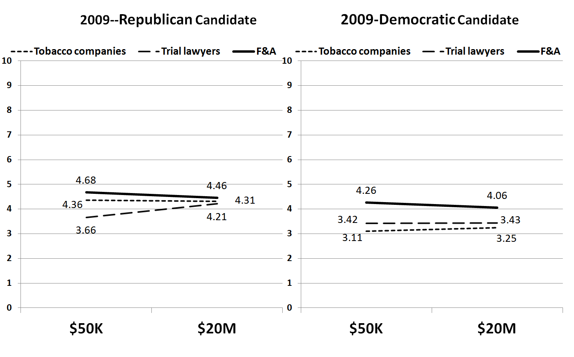

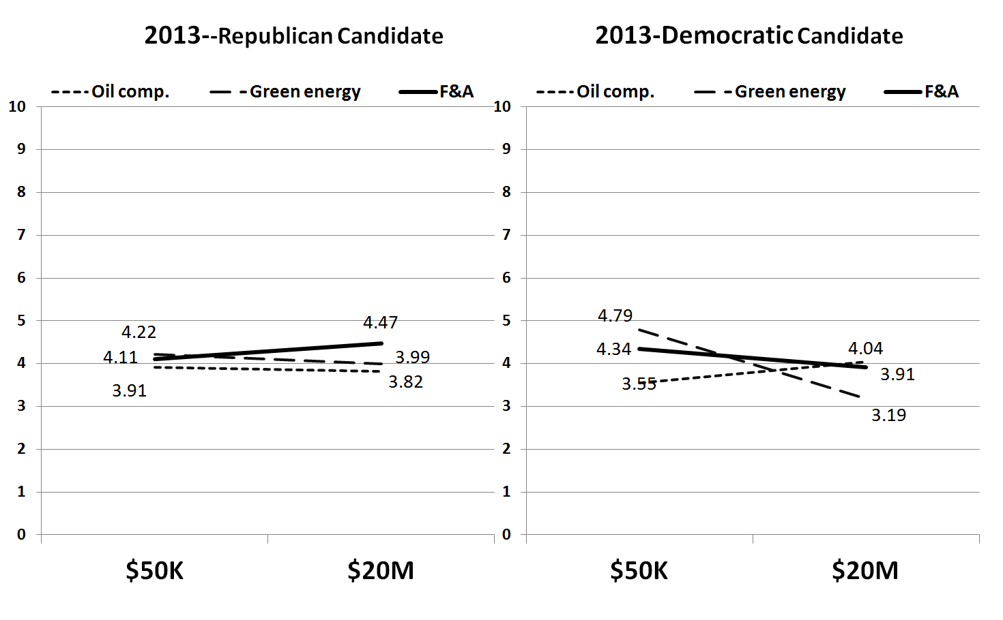

Figure 2A—Voting Likelihood for Jones by Contribution Source, Amount, and Candidate Party (by Respondents’ Party Identification) in 2009

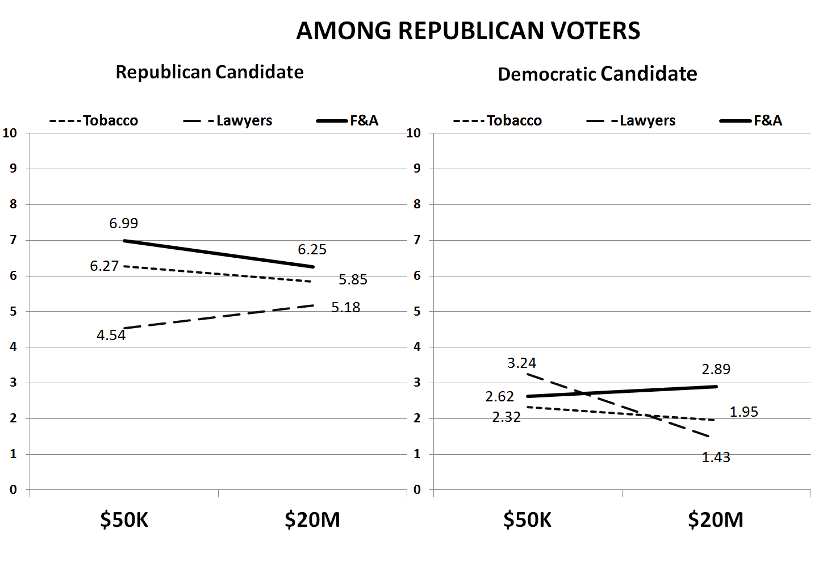

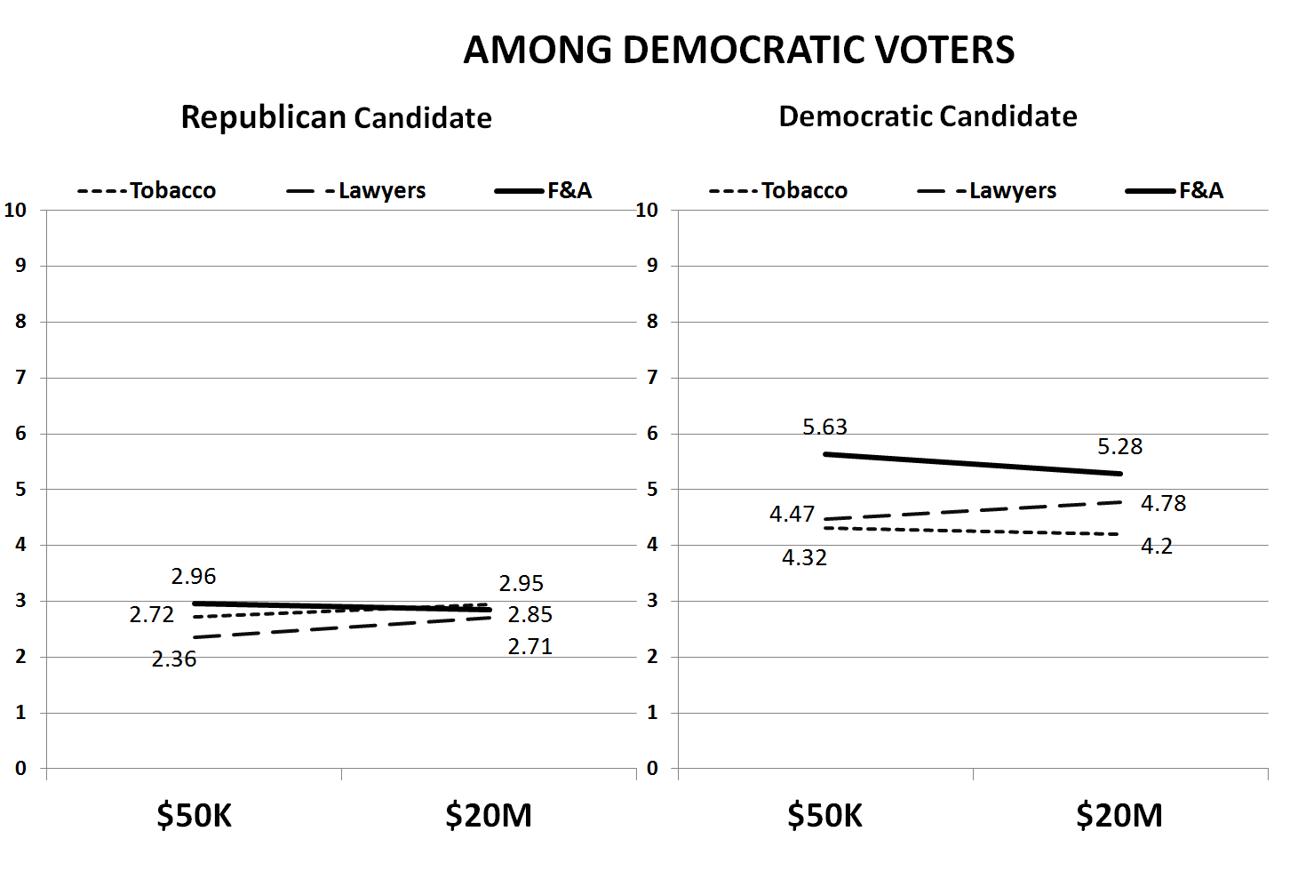

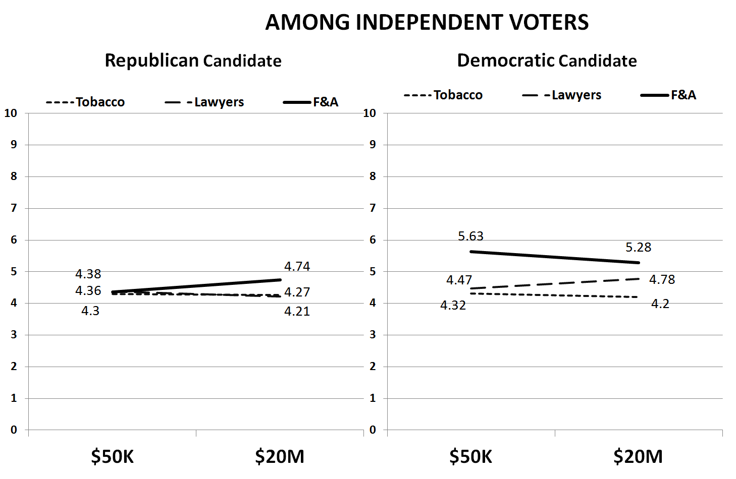
Figure 2B—Voting Likelihood for Jones by Contribution Source, Amount, and Candidate Party (by Respondents’ Party Identification) in 2013

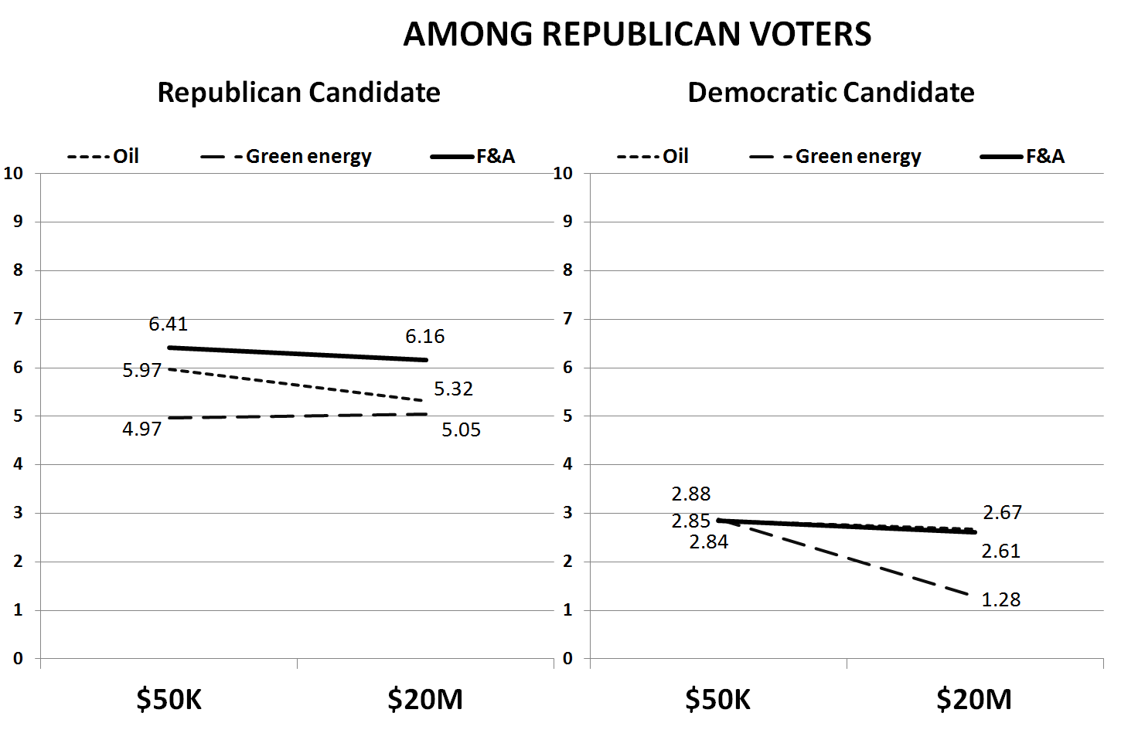

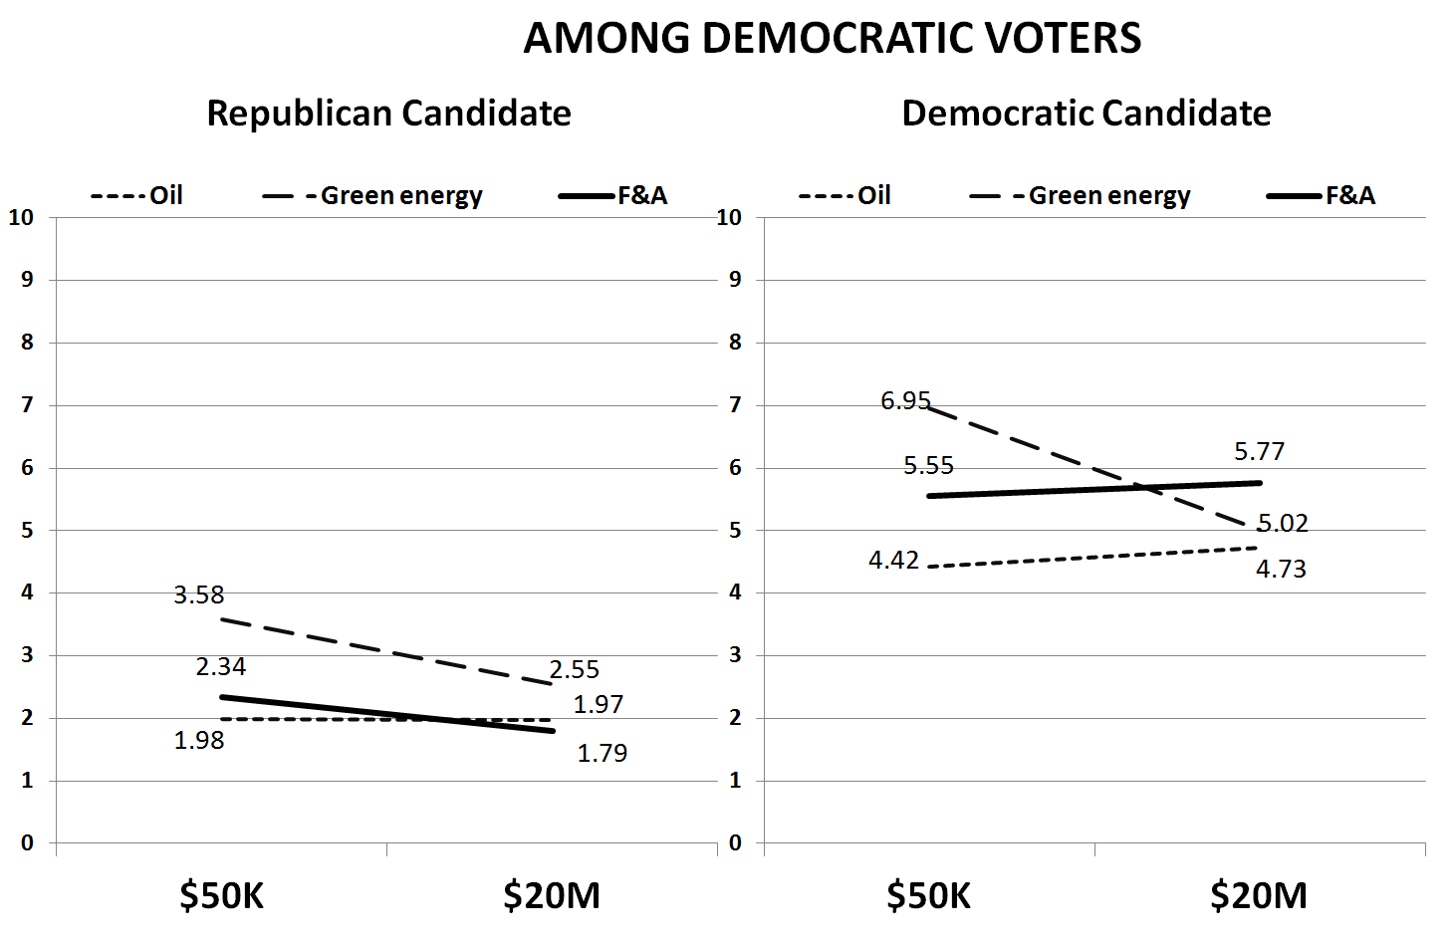

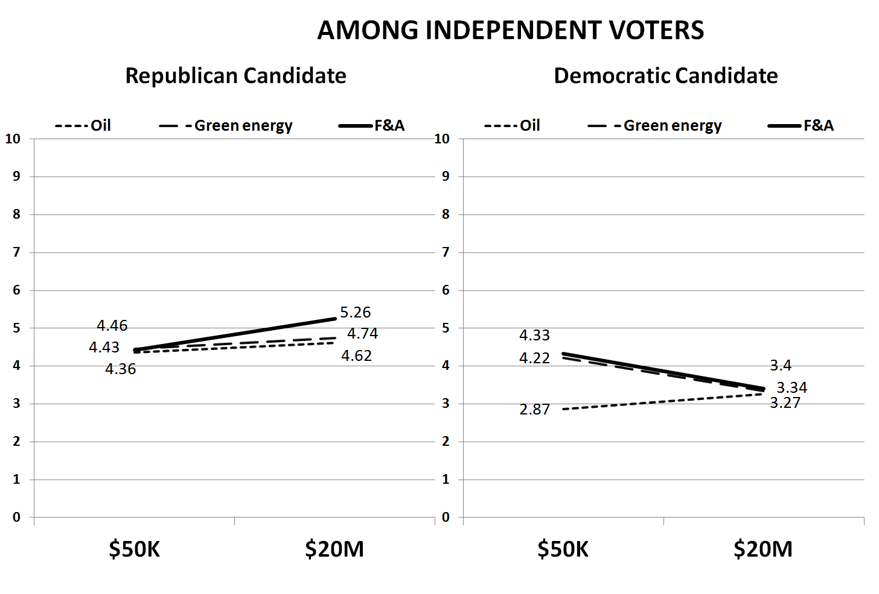

Table 2—Predicting Support for Candidate Jones by Treatment (2009)
VARIABLES | Base (All) | All | Republicans | Democrats | Independents
Tobacco | -0.933*** | -1.803*** | -1.447** | -1.835*** | -1.833***
 | (0.172) | (0.305) | (0.605) | (0.443) | (0.594)
Trial lawyers | -0.885*** | -1.326*** | -1.858*** | -1.121** | -1.058*
 | (0.173) | (0.305) | (0.617) | (0.450) | (0.578)
$20 million | -0.0230 | -0.0459 | -0.158 | 0.00167 | -0.113
 | (0.139) | (0.148) | (0.284) | (0.229) | (0.271)
Republican candidate | 0.486*** | -0.391 | 1.364** | -1.947*** | -0.477
 | (0.170) | (0.309) | (0.611) | (0.465) | (0.586)
Democratic candidate | -0.0230 | -0.688** | -2.249*** | 0.719 | -0.663
 | (0.139) | (0.308) | (0.599) | (0.449) | (0.630)
Tobacco X Republican |  | 1.725*** | 0.750 | 2.111*** | 1.825**
 |  | (0.421) | (0.811) | (0.638) | (0.791)
Tobacco X Democrat |  | 0.797* | 0.717 | 0.802 | 0.668
 |  | (0.423) | (0.821) | (0.630) | (0.821)
Trial lawyer X Republican |  | 0.785* | 0.209 | 0.706 | 1.133
 |  | (0.424) | (0.829) | (0.662) | (0.767)
Trial lawyer X Democrat |  | 0.463 | 2.069** | -0.00662 | -0.512
 |  | (0.480) | (0.921) | (0.744) | (0.890)
Trial lawyer X Democrat X $20 M |  | 0.0792 | -1.641* | 0.336 | 0.700
 |  | (0.439) | (0.911) | (0.700) | (0.753)
Republican respondent | 0.254 | 0.229
 | (0.179) | (0.179)
Democratic respondent | -0.402** | -0.431***
 | (0.165) | (0.165)
Age | -0.0205 | -0.0137 | -0.00584 | -0.0246 | 0.109
 | (0.0568) | (0.0567) | (0.109) | (0.0882) | (0.106)
College | -0.0590 | -0.0584 | -0.318 | -0.109 | 0.0930
 | (0.151) | (0.151) | (0.289) | (0.239) | (0.272)
Union | 0.327* | 0.350* | -0.278 | 0.553** | 0.361
 | (0.194) | (0.194) | (0.405) | (0.274) | (0.356)
Female | -0.239* | -0.261* | -0.00341 | -0.294 | -0.244
 | (0.144) | (0.143) | (0.279) | (0.221) | (0.263)
Income | -0.00550 | -0.00261 | 0.209 | -0.179 | -0.119
 | (0.0889) | (0.0887) | (0.164) | (0.142) | (0.166)
Knowledge | -0.199 | -0.164 | 0.147 | -0.527 | -0.844*
 | (0.256) | (0.256) | (0.503) | (0.432) | (0.452)
Corruption | 0.170*** | -0.175*** | -0.203*** | -0.184*** | -0.109
 | (0.0393) | (0.0392) | (0.0747) | (0.0597) | (0.0744)
Constant | 6.069*** | 6.547*** | 6.453*** | 6.709*** | 6.432***
 | (0.404) | (0.433) | (0.844) | (0.641) | (0.773)
Observations | 1,442 | 1,442 | 369 | 498 | 417
R-squared | 0.057 | 0.069 | 0.276 | 0.174 | 0.092
Standard errors in parentheses; *** p<0.01, ** p< 0.05, * p< 0.1
Table 3—Predicting Support for Candidate Jones by Treatment (2013)
 | Base (All) | All | Republicans | Democrats | Independents
Oil | -0.554*** | -0.686** | -0.477 | 0.239 | -1.463***
 | (0.171) | (0.298) | (0.554) | (0.484) | (0.452)
Green energy | -0.335* | -0.174 | -1.924*** | 1.801*** | -0.545
 | (0.171) | (0.301) | (0.583) | (0.502) | (0.421)
$20 million | -0.124 | 0.0759 | 0.0715 | -0.0788 | 0.209
 | (0.141) | (0.149) | (0.286) | (0.232) | (0.224)
Republican | -0.395** | -0.353 | 1.086** | -1.092** | -0.591
 | (0.172) | (0.293) | (0.530) | (0.492) | (0.433)
Democrat | -0.281 | -0.267 | -1.532*** | 2.017*** | -1.236***
 | (0.173) | (0.294) | (0.579) | (0.482) | (0.415)
Oil X Republican |  | 0.0114 | -0.702 | -0.353 | 1.188*
 |  | (0.421) | (0.757) | (0.676) | (0.648)
Oil X Democrat |  | 0.350 | 0.225 | -1.074 | 0.970
 |  | (0.423) | (0.835) | (0.656) | (0.643)
Green X Republican |  | -0.128 | 0.733 | -1.072 | 0.405
 |  | (0.422) | (0.814) | (0.683) | (0.628)
Green X Democrat |  | 0.546 | 1.164 | -0.491 | 0.787
 |  | (0.480) | (0.924) | (0.780) | (0.683)
Green X $20M X Democrat |  | -1.750*** | -1.833** | -1.647** | -1.302**
 |  | (0.450) | (0.820) | (0.756) | (0.647)
Republican respondents | 0.00793 | 0.0243
 | (0.186) | (0.186)
Democratic respondents | -0.373** | -0.387**
 | (0.162) | (0.161)
Age | -0.012*** | -0.012*** | -0.018** | -0.011 | -0.018***
 | (0.0044) | (0.0044) | (0.0084) | (0.0069) | (0.0068)
College | 0.0275 | 0.0322 | -0.110 | -0.134 | -0.0249
 | (0.176) | (0.176) | (0.325) | (0.288) | (0.261)
Income | 0.0539** | 0.0497* | 0.0403 | 0.0520 | 0.0414
 | (0.0269) | (0.0268) | (0.0496) | (0.0423) | (0.0412)
Female | 0.150 | 0.139 | 0.350 | 0.403* | -0.329
 | (0.147) | (0.148) | (0.284) | (0.230) | (0.227)
Knowledge | -0.104 | -0.107 | -0.198 | -0.221* | -0.0655
 | (0.0733) | (0.0731) | (0.140) | (0.115) | (0.112)
Corruption | -0.505*** | -0.492*** | -0.288* | -0.436*** | -0.512***
 | (0.0851) | (0.0851) | (0.158) | (0.138) | (0.129)
Constant | 5.719*** | 5.629*** | 6.223*** | 4.291*** | 6.541***
 | (0.327) | (0.343) | (0.742) | (0.509) | (0.487)
Observations | 1,520 | 1,520 | 318 | 617 | 585
R-squared | 0.055 | 0.066 | 0.291 | 0.234 | 0.098
Standard errors in parentheses; *** p<0.01, ** p< 0.05, * p< 0.1

424 U.S. 1 (1976).
The informational role of campaign finance information has been long featured in theoretical models (Ingberman 1992; Coate 2004; Ashworth 2006). Researchers have also demonstrated the ability to recover the ideological positions of candidates using campaign contribution information (McCarty and Poole 1998; Boncia 2013), but these impressive results do not speak to the effect such information has on voter behavior.
The appellants did not seek the elimination of disclosure laws per se but claimed that those in FECA were overbroad, burdening small parties and independent candidates in particular. In fact, the appellants went so far as to argue that well-crafted disclosure rules alone were sufficient to address concerns about the role of money in politics.
The remaining arguments centered on the deterrence of corruption and enforcement of campaign finance laws.
The negative manifestation of this is “guilt by association.” Despite the fact that political consultants commonly attempt to prod this in campaigns (e.g., Republican efforts to tie Barack Obama to Reverend Jeremiah Wright and William Ayers in 2008, and Democratic efforts to tie Mitt Romney to Senator Larry Craig in 2012), there is surprisingly little systematic empirical evidence that voters downgrade candidates based on their less well-regarded associates.
A complete description of the survey methodology is available upon request from the authors.
Although Chris Jones is an androgynous name, the candidate is identified as “he” in the news story.
McCutcheon vs. Federal Election Commission, 572 U.S. ___ (2014), overturned aggregate contribution limits, but left in place limits on contributions to individual candidates established under the 2002 Bipartisan Campaign Reform Act.
As mentioned earlier, because of federal campaign contribution limits, neither an individual nor a political action committee (PAC) can make either a $50K or a $20M contribution to a candidate in a given election cycle. Multiple donors from a particular industry, however, can make donations together to a PAC or they can “bundle” their individual contributions to signal a common (e.g., industry) affiliation. As with any experiment, there is always the question of external validity. Our treatment consists of substantial contributions from a narrow range of specific sources, contributions that may strike the informed observer as rare. There is, however, ample evidence—both in the literature and in our own data—that voters know next to nothing about the particulars of campaign contributions and that the news media greatly and systematically exaggerate the magnitude of campaign contributions (see, for example, Ansolabehere, Snowberg, and Snyder 2003). We expand on how generalizable our study is later on.
These allow us to ascertain the impact of receiving contributions from well-regarded versus noxious groups. Of course, contributions from corporations cannot come directly from their treasuries, rather they must come from affiliated political action committees, through which no corporate money can flow. Note also that we are not directly measuring perceived corruption. Rather, we gauge whether information about “extreme” campaign contributions affects voters.
Although we do not directly measure mobilization with a turnout variable, we assume that greater enthusiasm by in-partisans towards their candidate correlates with a higher turnout probability.
The story was based on an actual Associated Press report, “Some Incumbent Senators Seem to Get No Respect” by Kimberly Hefling, July 26, 2009 (last accessed on 7/26/2010 at http://www.usatoday.com/news/washington/2009-07-25-senators-primarychallenge_N.htm).
When examining treatment effects by party identification, cell sizes average approximately 35 cases.
These results reflect expressed rather than revealed preferences. Furthermore, it is at least possible that Democrats are relatively willing to state that they would punish their own candidates for taking money from undesirable sources, but these voters may not actually follow through on that threat when casting their actual ballot.
The differences in support for green energy versus other funding sources are statistically significant at a p< 0.01 level.
Specific items used to create these scales are available in the online Appendix.
We did not ask a union household item in the 2013 survey, so it is not included in the 2013 model.

